Architect

Yasmen emad adel el abd

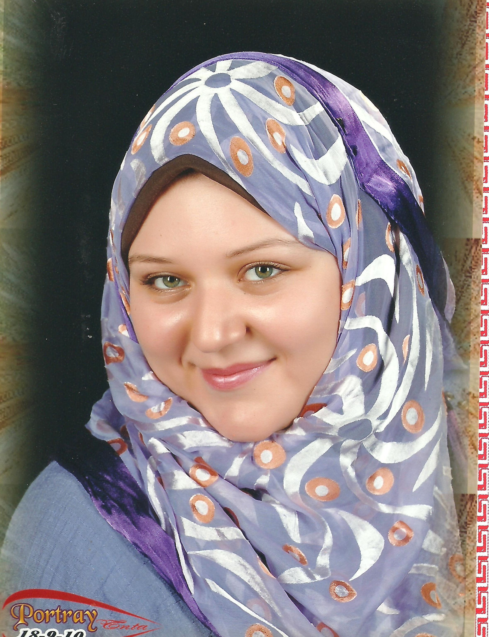
CV
NAME yasmen emad adel el abd
ADDRESS |  | 10 , the end of saeed st, Tanta,EL-GHARBIA - Egypt
DATE OF BIRTH |  | 5 -11 -1988
PLACE OF BIRTH |  | Egypt-el Gharbya- tanta
NATIONALITY |  | Egyptian
CONTACTS |  | Tel 0403311614
 |  | Mob: 01091047573
 |  | E-mail
EDUCATION
2010 |  | B.A, Bachelor of Architecture,  Faculty of Engineering, Tanta University – Tanta , Egypt
Grade/ Rank |  | Granted the Degree of Bachelor of Architectural Eng. in July 2010 with a Commutative Rate of Appreciation:  Very Good(75.6).
Graduation  Proj. Degree: |  | Good (68.29) .  Graduation Proj : Business & finance center
Graduated as an Architect at July 2010
- 4 years of engineering /Architectural study, 8 months each year, final graduation project.

- Main subject was Architectural Design, Working Drawings, Architectural Theories, and Urban Design.

- Other Subjects: Steel Structure, Concrete Structure, Landscape, Planning, Environmental Studies, Building Materials, Rural Development, Sustainable Studies Working Drawings .
Languages |  |  | English :  Arabic : |  | Written & Spoken.  Mother tongue.
Affiliations |  |  | Member of the Egyptian Engineers Syndicate.
PROFESSIONAL SKILLS
General skills |  |  | - Professional architectural design experience, providing Interior and Exterior Architectural design for all kind of projects.
General skills |  |  | - Prepare Reports, the Design Criteria &Technical Research. And take responsibilities in Data Collection for all kind of projects.
General skills |  |  | - Prepare and design Working Drawing, Work-Shop Drawings, Details and Specifications.
General skills |  |  | - As build drawings for existing buildings, Renovation Architecture Design.
General skills |  |  | - Design Presentations, submittals & portfolios in all presentation types like:  (Boards, A3 or A4 reports, PowerPoint, video).
General skills |  |  | - Using the following equipment and software professionally to produce the final product .
Equipment |  |  |  | Digital & Optical Cameras, Video Cameras, Laser & Inkjet Printers, Plotters.
Software |  |  |  | Autodesk  - AutoCAD 2d- 3d ( as a professional )  - 3d-max ( as a professional )  - Revit architecture (as a professional)  - Fusion (as a workable).  - Sweet home (as a professional).  - Kitchen design (as a professional).  Adobe  - Photoshop (as a professional)  Office  - Word ( as a professional )  - PowerPoint ( as a professional )  - Excel ( as a workable )

Experiences
Worked as an Architect (Design, Working Drawings and Presentation Media)
- El andalos group - dr. Osama konber
As an Architect. From July 2009 till October 2009 date
- شركة اسكان للتخطيط والاستثمار العقارى
As an Architect.
- Exterior and intarior design( El shehawy mall ) for ESKAN for Architecture & planning company Tel. +2 – 040 – 9115770
- Exterior design( el kodah tower ) for ESKAN for Architecture & planning company
- Exterior and intarior design(Design of Tut Ankh Amon tower ) for ESKAN for Architecture & planning company
- Exterior design ( ELEV and plan. Design of El – kornish tower ) for ESKAN for Architecture & planning company
- Exterior design and intarior ( ELEV and plan. Design of El – Nadi tower ) for ESKAN for Architecture & planning company
- Exterior design and intarior ( ELEV and plan. Design of El – SOLTAN MORAD tower ) for ESKAN for Architecture & planning company
- Exterior design ( ELEV and plan. Design of El – EBN ELFARD tower ) for ESKAN for Architecture & planning company
- Exterior design and intarior ( ELEV and plan. Design of El – NHAS tower ) for ESKAN for Architecture & planning company
- Exterior design and intarior ( ELEV and plan. Design of KTOOR tower ) for ESKAN for Architecture & planning company
- Exterior design and intarior ( ELEV and plan. Design of Ali Mubarak tower ) for ESKAN for Architecture & planning company
- Exterior design and intarior ( ELEV and plan. Design of Gardinia tower ) for ESKAN for Architecture & planning company
- Exterior design and intarior ( ELEV and plan. Design of El-Amal Compound ) for ESKAN for Architecture & planning company
- Exterior design and intarior ( ELEV and plan. Design of El-Estad tower ) for ESKAN for Architecture & planning company

- شركة الرياض للبناء والتشييد
As an Architect.
- Exterior design (ROMEL COMPOUND )IN MATROH.
- Exterior design (EL REYAD COMPOUND)IN ASWAN.
- INTERIOR DESIGN IN THIS RROJECTS.
- Exterior design and interior design for el estad tower.
- Unit arch group
As an Architect. From march 2010 till October 2010 date.
- Interior design of villas.
- Ras sedr school.

- E.e.g company
As an Architect
- El oroba mall (carfor tanta).
- Aveno café .
- Yam yam restaurant .
- Diesel cloth store .
- Green café .
- Future tower.
- Town team clothes factory.
- Capital school.
- El hyah mall in Bnha .
- Skwag club in Tanta.
- A lot of interior design .
- شركة الاستاذ للاستثمار العقارى
As an Architect
- Fesha compound.
- Hasn Radwan tower .
- Sayd bawdy tower.
- Ahmed Maher mall.
- Arch vision company
- Interior and exterior design .
- Finishes .
- Graphic design.
- Graphic courses.

Job Duties | - Charging for making a full design, managing and Co-coordinating the different kinds of engineering trades & drawings, Structural, Plumbing, HVAC, Electrical, Landscape  - Studying all the client requirements, queries, fulfilling what is possible and according to standards, replaying with reasons and other alternatives for the out of standards requirements.
PORTFOLIO (available on request )

