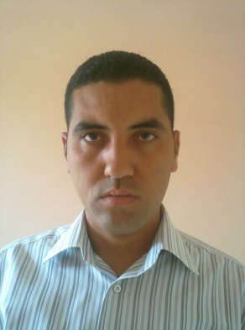
Eid hamdy Abu elkhair
Address: Ayyat, Giza, Egypt
Mobile: (01062064866 – 01127429298)
Tel: (02)38060437
Email: eidhamdy505@gmail.com
Objective:
- I would like to join to a corporation looking for a person with high skills, motivated and high performance standard to work for.
Education:
- Bachelor degree of commerce
- Section: Accounting
- Grade: good
- Cairo University, faculty of commerce, Cairo, Egypt
Skills:
Professional experience:
- Diploma in training program for computer accounting sponsored by the Egyptian institute for accounting, auditors, computer technology center.
Language skills:
- Good command of both written and spoken English
Experience:
- Aug 2006 till now: real-estate marketer in trust group.
Interests
- Football, horse hiking and swimming
Personal information:
- Date of birth: 28/12/1980
- Marital status : married
- Military service: exempted
- Religion : Muslim

