C.V.
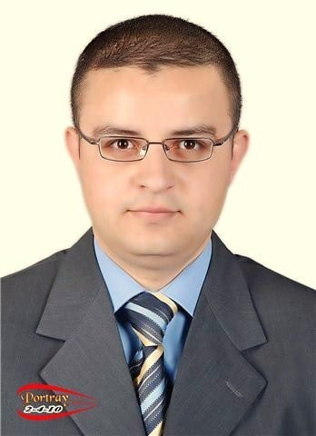
Name: Mohamed Mostafa Ahmed.
Gender: Male.
Date of Birth: 12-05-1981 (35 years old)
Address: Nasr city, Egypt.
Military Status: Exempted.
Marital Status: Single.
Nationality: Egyptian.
Mobile No. : +2 0100 4949 217
+2 011 555 86128

E-mail: developget@hotmail.Com

Personal Profile:
- I have been involved in activities such as Customer service, Administration, Training and recruitment.
- I have also previous experience in sales field.

Career Objective:
- Applying for a full time Position to gain more practical experience.

Education:
- Bachelor of commerce Accounting department.
- Working on Completing my Mini MBA in Human Resources Management.

Courses and certificates:

- Professional certificate in ''Human Resources planning''.
- Professional certificate in ''Training and Development''.
- Professional certificate in ''Organizational Behaviour''.
- Experience certificate in "Recruitment".
- "Effective Communication skills'' course.
- Assistant practitioner of NLP by C.T.C.
- Technical analysis course from commercial syndicate.
- TOT course certified by ICNLP.
Work experience:
Panoramic and Cephalometric X-ray dental centre.
- Position: Sales and Cs Supervisor.
Responsibilities:
- Selling and helping Customers Inquiries and Complaints if occur.
- Supervising workflow and helping colleagues and customers.
- Reporting to the centre’s manager about the performance.
- Insuring that everything is in order and solve the sudden issues that may occur during the day.

- Time: from 1-2010 till Now.


Masa Vodafone: an agent for Vodafone Egypt.
- Position: Corporate Sales Executive.
Responsibilities:
- Selling and promoting Vodafone products and services.
- Time: from 5-2009 till 11-2009

Blue Light Telecom: a partner for T-Mobile Company in Amsterdam, Holland.

- Position: Customer service Officer.
Responsibilities:
- Helping clients and satisfy their inquiries.
- Making contracts for new customers and renewals for current customers.
- Prepare action plans to clarify any obstacles that may happen, follow up pending cases and mails to and from head office and helping my team to improve branch profitability.
Time: from 9/2005 to 11/2007.
Computer skills:
- Microsoft Office (Word, Excel, PowerPoint, Access).

Language skills:
- Arabic: First language.
- English: Very Good (Spoken, Read & Written).
- Dutch (Netherlandse): Fair command (Spoken, Read & Written).

Personal Skills:
- Interactive and fast to learn new technologies.
- Planning ahead skills.
- Hard worker.
- Results oriented.
- Ability to work in cooperative groups.
- Ability to work under pressure.
- High communication skills.
- Time management skills.
- Problem solving skills.
Interests:
- Running.
- Reading in Arabic and English.

References:
- Available upon request.

