Curriculum Vitae

**-** Personal data

Name: Mohamed Fathy Ramadan Saleh Omar.

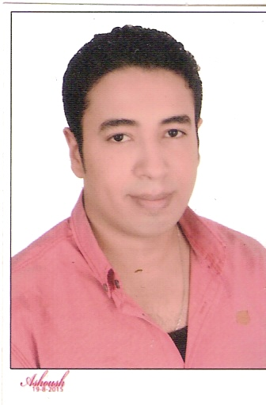

Address: tanta

Mobile: +201006777568

Date of Birth: 18/ 05/1988

Nationality: Egyptian.

Religion: Muslim.

Finished Military Service.

Valid Visa : 20- 07-2016

***E-mail:*** [***Mohamed_fat7y2009@yahoo.com***](mailto:Mohamed_fat7y2009@yahoo.com)

- Qualifications

**Academic Qualifications:** Bachelor of Commerce - Division of Information Systems and Management - Class of 2010 .

- Professional experience

- Previous post (1): Sales Representative in zahabia company for tourism Development & Real Estate Marketing

-Previous post (2): Salesperson in Zahabia Company for Tourism Development & Real Estate Marketing

- Previous post (3): Supervisor In Zahabia Company for Tourism Development & Real Estate Marketing

- Previous post (4): Deputy Sales Manager in Zahabia Company for Tourism Development & Real Estate Marketing

- Previous post (5): Sales Manager in Zahabia Company for Tourism Development & Real Estate Marketing

- Previous post (6): Sales Manager in Zahabia Company for Tourism Development & Real Estate Marketing in hurghada.

- Previous post (7): General Manager in Zahabia Company for Tourism Development & Real Estate Marketing in hurghada – Egypt .

- Previous post (8): General Manager in Meraj Company for Tourism Development & Real Estate Marketing in Kafr-Alsheikh – Egypt .

- Previous post (9): General Manager in Venessia Company for Tourism Development & Real Estate Marketing in Tanta – Egypt .

- Scientific expertise

* ICDL Computer.
* Marketing and Sales .
* Custmer service at Arabia online for securities trading.

- Languages and skills

• Arabic language (mother tongue)  
• English ( good)  
• Computer skills (excellent)  
• Sales  
• Teamwork  
• Leadership

- Personal Qualifications

- Good communication skills  
- Working under pressure  
- Driving License

- commitment

**I wish to join your team work**