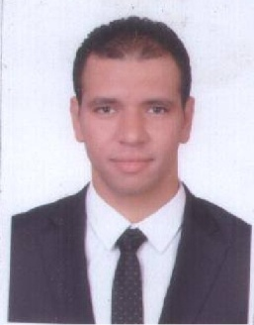 **Mahmoud Ahmed Sayed Abo Taleb**

**Mobil Number** : - (+20) 010 027 788 54  
 **E-mail** :-mahoudahmed99976@gmail.com  
 **El Giza, Egypt**

**Objective**

• Seeking employment with a company where i can use my talents and skills to grow and

Expand the company.  
• I want to be part of the success in an environment of growth and excellence.

• Looking for a position in marketing where i will use my skills and experience in sea and social media to increase site traffic and propel your company’s growth.

**Education**

* October2002- May2008 Graduated from high institute of social work
* October1999 -May2002 Thanwya Salah Salem, secondary school for boys.

**Work Experience**

• 2016 Right now working for Xceed out sourcing for TEdata as customer service

* 2015 - 2016 Worked for the united company of pharmacists as sales man

•2013 - 2014 Worked for French trade company for spare parts as sales man.

•2011 – 2012 Worked for Dokki Radiology center as marketing.

•2009 - 2011 Worked for Post Distribution company as sales man.

**Skills**

**• Soft skills:-**

* + Ability to work as an effective team member.
  + Ability to learn new rules and skills quickly.
  + Ability to communicate at professional level.
  + Self-motivation and ability to take initiative.
* **Language skill:-**
* Arabic : mother language
* English **:**B1as per common European farm work ofreference for language

• **Computer skills:-**

* + MS : - very good in using (Word, Excel, Power point, and outlook).

O Google drive : - very good.

**Activities and courses**

* English course Ministry of Defense language institute.
* I volunteered in Masr El Kheir foundation.

**Hobbies**

• Playing sports.

• Reading novels.

•Listening to music.

**Personal Information**

• **Date of birth** : 2, APRIL 1985.

* **Nationality :** Egyptian.
* **Military status :** Exempted.
* **Athletic**

**References**

• Furnished upon request.