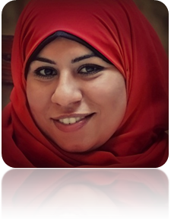
Mayada Said Elsayed Ebraheem Ahmed
Qualifications:
2009 - 2010 : Diploma in Public Law .. Grade: D//.
2005 - 2008: Faculty of Low, Menofia University .. Grade: D.
Experience:
2012 - 2013: Networker .
2009 - 2011: 2 years training in a lawyer office in high court .
Courses:
- English.
- ICDL.
- Communications Skills.
Skills:
Computer skills:
ICDL.
Language:
Arabic language: (Mother language).
English language: Good (written & spoken).
Address :
13 A, Sekket bany taye st., El-Zatoon, Cairo, Egypt.
Tel:
(+20) 24511137
Mob:
01006827025
E-mail address:
Anameka.Bahr@Gmail.com
Personnel Data:
Date of birth | October 15, 1987
Place of birth | Riyadh, Saudi Arabia
Religion | Muslim
Marital status | Single

Hobbies :
- Travel .
- Walk sport .
- Swimming .
- Sky Diving .

