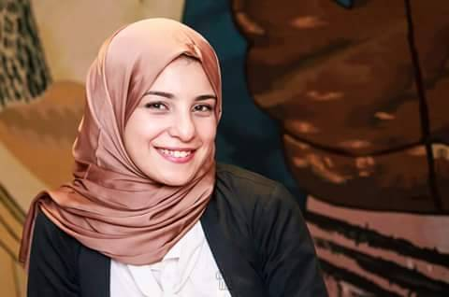 Ebtehal Ebrahim Gaber
e-mail- ebtehalebrahim25@gmail.com , Ph No: 01129259025
Nasr City Ahmed Fakhry Street ___________________________________________________________________________
Objective: Seeking a challenging position in your esteemed organization where my technical liaison and co-ordination skills can be effectively utilized to improve operations and contribute to the company’s growth.
Personal Skills:
- Good verbal and written communication skills
- Ability to work hard
- Ability to build motivation
- Creative & self-confident
- Positive approach thinking
Educational Qualification:

Bachelor of Commerce, Marketing Department, Zigzag University, May 2014
- American English Course
-Presentation skills
-Successfully completed a preparation Course for Non-Banking financial services industry & stock exchange from (May to June 2014).
-Successfully completed ICDL course at Zigzag University.
HR diploma
Social media
SOFT SKILLS:
- Good user of Windows, Microsoft Office ,Excel
- Basic in computers
- very good knowledge of the internet
Training:
Company : Bloom Bank Egypt, Mansura Branch
Duration : 2 months. From August to September 2013
Job Description: customer service

WORK EXPERIENCE:

Company: Office Executive at Evorestte till date

Company: 1- Empire advertising Coordinator & HR.
Experience: From 1 January 2016

Company: 2- TE data Data base
Experience: From 1April to 30 December 2015

Company: 3- Egyptian Life Takaful GIG Company Department Financial Blanner
Experience: From 1 July to 30 December 2014

Personal Details:

Date of birth : 7 July 1992
Sex : Female
Marital Status : Single
Nationality Egyptian
Hobbies : Listening Music, reading novels, Playing Games.

DECLARATION :

The above mentioned information is true and correct to the best of my knowledge and belief. If I am selected and given a chance to serve in your esteemed organization I shall prove my best and ability to the entire satisfaction of my superiors.

