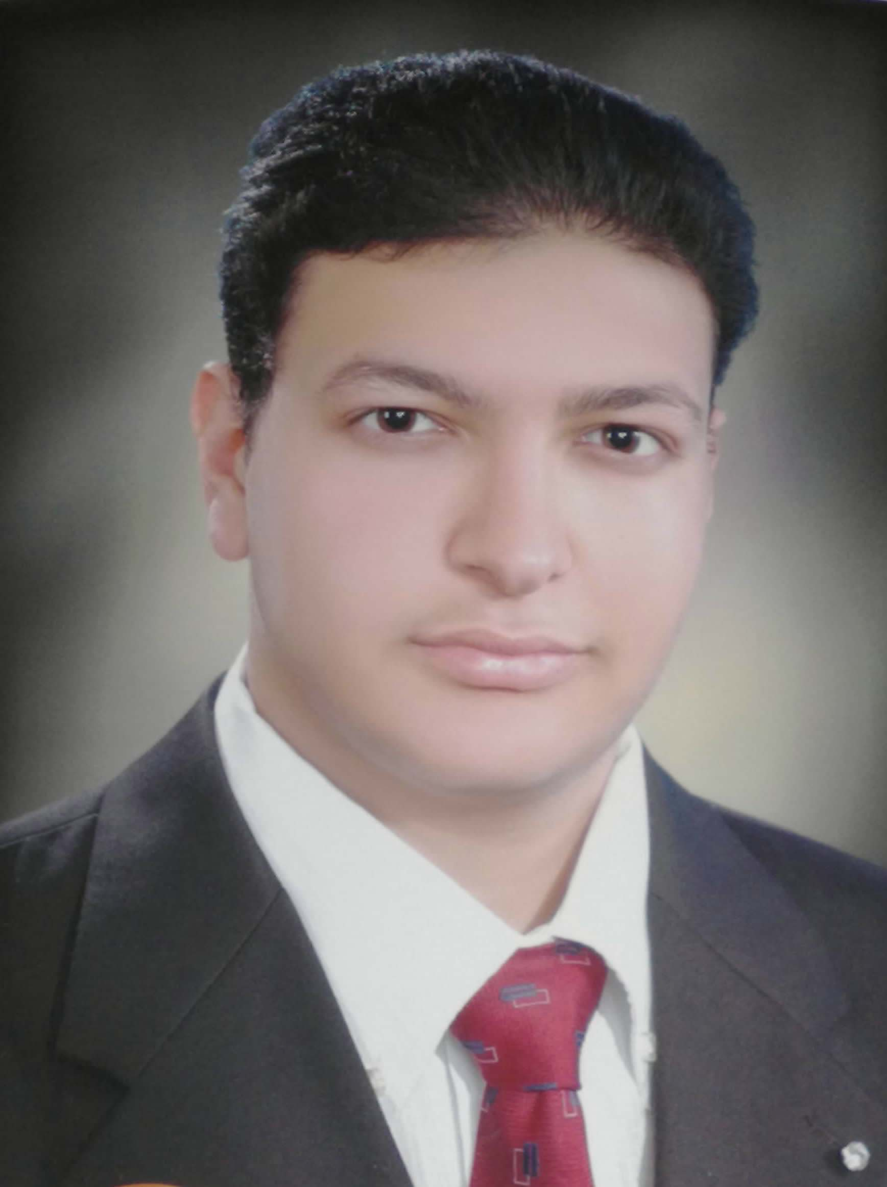 Name/ Mostafa Mahemoud ElE_tkawy

Contact Information
- Address: Ebyar,kafr_Ezayat,Gharbia,Egypt.
- Mobile: 0183640753
- Email :nostafa_asd_2020@yahoo.com

Civil engineer

Personal Information
Date of Birth : 19 / 3 / 1991
Place of Birth : Gharbia
Gender : Male
Marital Status : Single
Nationality : Egyptian.
Resident : Ebyar,kafr_Ezayat,Gharbia,Egypt.
National ID : 29103191600773
Military service : Delayed – postponed

Education
Educatin : Bachelor in civil engineering.
Degree : Very good with honors.
University : Tanta University .
Date of graduation : 2012/2013
No.Union : 02 607/47

Graduation project :
Title : mechanical foundation project
Degree : Excellent

Language Skills :
Arabic : Mother language .
English : Good .

Computer skills:
- AutoCAD 2D. - Sap 2000 .
- PCA program . - Microsoft Office (word, excel, PowerPoint).
- Ability to perform under pressure & time constraints.
- Quick learner , hard worker.

Work Experience :
- Summer 2010 as a trainer in a project for the establishment of a residential Building
- Experience in using surveying tools ( Theodolite ).
- Experience one year in infrastructural Cooperative Society productivity Engineering Consultancy
- Worked one year at the Ministry of Water Resources and Irrigation of 2014-
2015
- An experience in lab. And field experiments of soil as well as making soil reports .

Trainig courses :

- Auto cad 2D program ( Egyptian syndicate of engineers ) .
- Sap 2000 program .
- Pca program .

