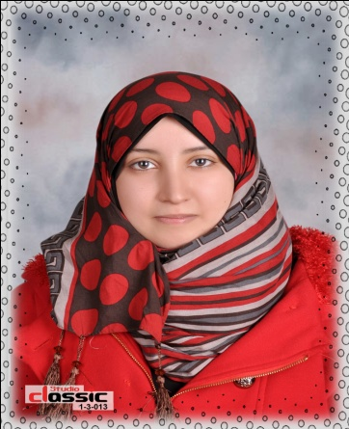 **Azza Hassan Shehata Andho**

Egypt - Tanta - Kafer Elzayat - Al Dalgamoun

(02)01010157059

[Eng_zoza_2008@yahoo.com](mailto:%20%20%20%20%20%20Eng_zoza_2008@yahoo.com)

22 Dec, 1990

**Personal Profile:**

I am just a person who dreams for a great future for me & for my country.

I am looking to become a member in a leading company, where my skills will be enhanced and developed ready to work in any field in anywhere to prove myself and I will continue studying in which I will work in.

**Education/Degrees**

**2013** Bachelor **in Architecture Engineering** Faculty of Kafr-Elsheikh University.

**GPA**: Good

**Graduation Project Title**:

"Research Center Aquariums Design Project in City Brolos"

**Project grade:** 95% _Excellent

**Project is supervised by:** Dr. Shareef Sheta

**Training and Courses**

**2010**  Certified as a **very good** user *AUTOCAD 2D.*

***2010***Certified as an **excellent** user *AUTODESK 3D MAX*.

**2012** Certified as an **excellent** user *REVIT Architecture*.

**Work experience**

**July 2012: Aug 2012** Dr. Abd El Rahman office for Architecture and Decoration

Trainee Engineer

**July 2013: Aug 2013** El Shora office for Architecture and Decoration

Trainee Engineer

**Languages Skills:**

* Arabic (mother tongue) * English (good)

**Computer Skills:**

*AutoCAD 2D/3D *3D Max *Revit

*Photoshop *Microsoft office (word_excel_powerpoint) *V-ray architecture

**Personal Skills:**

Hard worker, creative, cooperative, ambitious and very fast learner.