Nesma Youssef Kadri Osman Afifi

Tanta.101 Sedki st.
.040 330 42 52
.012 018 344 97
Nesma-Youssef@hotmail.com
Objective
A challenging career opportunity in the field of customer services that would give me the chance to be an effective member of creative team in a successful progressive organization.

Education
University Faculty  Major  Accumulative Grade | Tanta University.  Faculty of Commerce (English section).  Accounting May 2011.  Good (70.13%).

Language Skills
Arabic  English | Mother language.  Very good.

Computer Skills
ICDL | 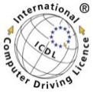  Microsoft Word, Excel, PowerPoint, Access, Window, IT,  Internet.

Training experience
Trainer Department |   Piraeus Bank.  Customer service department.  Sept.2010

Courses
Egyptian Banking Institute  Conversation English Course  EDU Egypt Program  Human Resource Course | Banking Training, Graduate Program (Egyptian Banking Institute)  - Introduction to banking system.  - Development of the banking sector.  - Role of the Central Bank of Egypt.  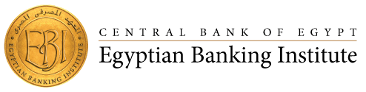  - Basic of banking operation.  - Bank accounts & deposits.  - Retail banking operation.  - Commercial paper.  - Customer services.  (For 97 hours From 1 April 2012 to 29 April 2012.  Advanced Level at American University in Cairo( AUC).  August 25 – October 24 , 2011    Certified by Ministry of communications and new horizons company  - Communication skills  - Presentation skills.  - Customer service.  - Business writing.  - Business English.    Youth Leadership Initiative  April 2009 (sponsored by Vodafone )

Current job
Current job  Previous job  Voluntary work | Customer Service advisor at Vodafone Egypt. (Since February 2014)  - Sell Voda products and provide customer with requested information.  - Handle all cases of multi-skills function(cash & inventory)  - Minimize & resolve customer problems, ensure quality of service.  Organizer at Nourmedia Organization for Medical Conferences from May 2012 to Aug. 2013  Organize Medical Conferences & meetings:  - Coordinate Conferences with professors  - Booking Hotels & transportation  - Sending formal e-mails & faxes  - Dealing with Pharmaceutical & Tourism Companies    A volunteer for El-Sharaia Charity.

Skills
Personal skills | - Ability to work under pressure.  - Ability to learn fast & achieve my tasks accurately.  - Ability to work in a group or individually.  - Good communication & Negotiation Skills.  - Social Personality, Cooperative, Self-motivated.

Hobbies
Personal hobbies | - Computer & internet.  - Listening music & Cooking.

Personal Details
Date of Birth  Nationality  Gender  Marital status | 24 / 11 / 1989  Egyptian.  Female.  Single.

References available upon request

Thank you….

