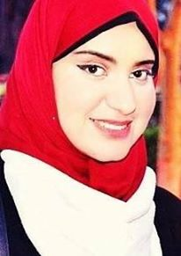 **Sara alaa el.deen Mohamed el.mahdy**

Reyad ghorabah.st, Tanta, Gharbia ,Egypt

**01017035463**

Saramahdy.resala@gmail.com

|  |  |
| --- | --- |
| **Personal Data** | |
| **Date of birth:**  **Marital status:**  **Gender:**  **Nationality:** | 1/10/1988  Single  Female  Egyptian |
| **Education** | |
| 1. - 2009 | * B.SC, Faculty of Basic Education,Tanta University.   Major:English  Grade :Totally / good |
| **Extracurricular Activities** | |
| 11\2015_Until 6\2016 | * Working as a Receptionist and a Customer Service Representative . * Working as an Executive secretary for the Executive director of Resala Charity . |
| **Courses** | |
| 2008  2010  2016 | * "ICDL" , at Infc . * Customer service Representative at Infc . * Soft skills and presentation skills at Resala Charity . |
| **Skills** | |
| **Computer**:  **Languages:** | MS Office 2010 , social media and internet .  **Arabic**: mother tongue.  **English**: good (spoken, written and translating). |
| Tasks of my last job : | |
|  | **As an executive secretary :**   * Schedule meetings and arrange conference rooms. * Greet and receive visitor. * Manage travel and schedule. * Prepare agenda for meetings. * Plans events and volunteer activities. * Receive and relay telephone messages. * Save and coordinate all data such as phone numbers and emails * Do office work , such as writing letters , speeches and acts of copying , printing and other * Prepare correspondence and stuff mail into envelopes.   **As a customer service :**   * Interact with **customers** on behalf of Resala charity * Provide information about services, take orders, respond to **customer** complaints, and process returns**.**   **References upon request** |
|  | |
|  |  |
|  | |
|  | |
|  |  |
|  | |
|  |  |
|  | |
|  |  |
|  | |
|  |  |