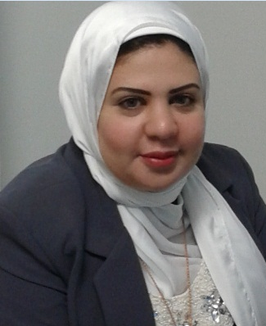  Ghada Abdo  Financial Analyst | 002-0122-6055417  Ghada.abdo82@gmail.com  9 selim St.Elzaytoon- Cairo  16/03/1982
Profile :
Seeking a challenging position in the Financial Advisory field, thus to utilize my experience, qualifications, ambition & skills, with the potential for continuous growth, offering excellent work proficiency, gaining more experience and getting new concepts.
.
Skills:
Financial Reporting
Fundamental Analysis
Financial Modeling using Excel
Corporate Finance
Investment Appraisal
Excellent knowledge of Microsoft Office Applications.
Experience:

Moore Stephens Egypt Jan 2014-present Equity analyst
1-Analyze financial information to produce forecasts of business, industry, and economic conditions for use in making investment decisions.
2-Interpret data affecting investment programs, such as price, yield, stability, future trends in investment risks, and economic influences
3-Prepare plans of action for investment based on financial analyses.

Bahnasawy Chartered Accountants and Tax Services 2010-2013 Accountant – Auditor
1-General Ledger duties:
• Preparing the monthly closing entries.
• Preparing monthly accounts reconciliations.
• Preparing monthly Trial Balance
• Preparing monthly Actual Cash flow.
• Monitoring the fixed assets movements and handling the fixed assets register.
• Handling all Inter-Company transactions and preparing the required Confirmations,
Statements & Reconciliation
• Handling the Quarterly and annually Audit process
2-Accounts Receivable duties: "supervision"
• Supervision the Invoices and Receipts issuance
• Reviewing on the A/R Weekly Report
• Dealing with all financial requests from customers
3-Reporting:
• Preparing MIS package "Management Information System"
• Daily cash position Report
• P&L Analysis Report
.
CFA level 1 Tutor 2012-2013
Freelance Training

Ames IT Academy

Instructor & Team Supervisor (2008- 2009)

1-Worked as a team member in Recording& preparing learning material and Full Explanation and practice, also Teaching Graphic package courses
2- Plan, prepare and deliver instructional activities that facilitate active learning experiences
3- Keep up to date with developments in subject area, teaching resources and methods and make relevant changes to instructional plans and activities

H.P.A (Highly Professional Advisor)
Part time Instructor (2008-2010)

Working on teaching English Accounting courses

Ahli United Bank
Administrative Secretary for the branch Manager (2004-2007)

1-Using a variety of software packages, such as Microsoft Word, Outlook, PowerPoint, Excel, Access, etc., to produce correspondence and documents and maintain presentations
2- Attending meetings, taking minutes and keeping notes
3- Ordering and maintaining stationery and equipment supplies, sorting and distributing incoming post and organizing and sending outgoing post

GSCCT, Tanta University
Instructor & Web Designer (2003-2004)

1-Worked as a team member for Web Designing (Faculties web sites, conferences & history books for foreign visitors), by adapting existing website software and graphics packages to meet business requirements
2- Test the website and identify any technical problems then upload it on servers
3- Instructor Working in Egyptian Graduation Project Scholarships (1400 hours) each

Education :
Tanta University 1998-2002
Bsc. of Commerce, English Section, Accounting Dep

Courses :

- CFA (Chartered Financial Analyst) level 1 pass (2011) & level 2 Exam Finished 2013
- Q.A.D ( Qualified Accountant Diploma) (September 2007)
- The International Computer Driving License, ICDL ® (2007)
- Human Soft Skills (People Management - Effective Business communication & writing skills – Teamwork& Interpersonal skills) (2006)
- Microsoft Office Suite course – (360 Hours) Score Excellent (2004)
- CIW 410 Certified Internet Webmaster (Internet – Network – Html) Score 98 % ( 2003)
- Certified Flash MX Designer - score 97% (2003)
- Graphic & Multimedia Development Attendance Certificate (2003)
- Egyptesol Convention Attendance Certificate as a Trainer & Presenter. In the Electronic Oasis November (How to design web site without needing a specialist) 2005

