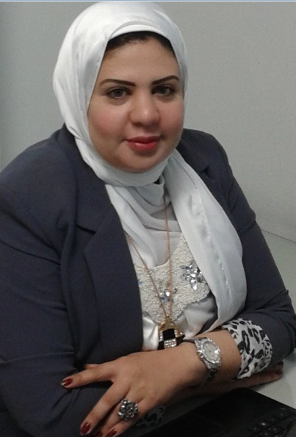  Ghada Abdo  Financial Analyst | 002-0122-6055417  Ghada.aziz82@gmail.com  9 selim St.Elzaytoon- Cairo  16/03/1982
Profile :
Seeking a challenging position in the Financial Advisory field, thus to utilize my experience, qualifications, ambition & skills, with the potential for continuous growth, offering excellent work proficiency, gaining more experience and getting new concepts.
.
Skills:
Financial Reporting
Fundamental Analysis
Financial Modeling using Excel
Corporate Finance
Investment Appraisal
Excellent knowledge of Microsoft Office Applications.
Experience:

Moore Stephens Egypt
Public Accountants & Consultants Jan 2014- present Research Analyst
1-Analyze financial information to produce forecasts of business, industry, and economic conditions for use in making investment decisions.
2-Interpret data affecting investment programs, such as price, yield, stability, future trends in investment risks, and economic influences
3-Prepare plans of action for investment based on financial analyses.

Bahnasawy Chartered Accountants and Tax Services 2010-2013 Accountant – Auditor
1-General Ledger duties:
• Preparing the monthly closing entries.
• Preparing monthly accounts reconciliations.
• Preparing monthly Trial Balance
• Preparing monthly Actual Cash flow.
• Monitoring the fixed assets movements and handling the fixed assets register.
• Handling all Inter-Company transactions and preparing the required Confirmations,
Statements & Reconciliation
• Handling the Quarterly and annually Audit process
2-Accounts Receivable duties: "supervision"
• Supervision the Invoices and Receipts issuance
• Reviewing on the A/R Weekly Report
• Dealing with all financial requests from customers
3-Reporting:
• Preparing MIS package "Management Information System"
• Daily cash position Report
• P&L Analysis Report
.
CFA level 1 Tutor 2012-2013
Freelance Training

IT Gate Academy

Instructor & Team Supervisor (2008 - 2009)

1-Worked as a team member in Recording& preparing learning material and Full Explanation and practice, also Teaching Graphic package courses
2- Plan, prepare and deliver instructional activities that facilitate active learning experiences
3- Keep up to date with developments in subject area, teaching resources and methods and make relevant changes to instructional plans and activities

Ahli United Bank
Administrative Secretary for the branch Manager (2004-2007)

1-Using a variety of software packages, such as Microsoft Word, Outlook, PowerPoint, Excel, Access, etc., to produce correspondence and documents and maintain presentations
2- Attending meetings, taking minutes and keeping notes
3- Ordering and maintaining stationery and equipment supplies, sorting and distributing incoming post and organizing and sending outgoing post

Education :
Tanta University 1998-2002
Bsc. of Commerce, English Section, Accounting Dep.

Courses :

- CFA (Chartered Financial Analyst) level 1 pass (2011) & level 2 Exam Finished 2013&2016 - Band 9.
- Q.A.D ( Qualified Accountant Diploma) (September 2007)
- The International Computer Driving License, ICDL ® (2007)
- Human Soft Skills (People Management - Effective Business communication & writing skills – Teamwork& Interpersonal skills) (2006)
- Microsoft Office Suite course – (360 Hours) Score Excellent (2004)
- CIW 410 Certified Internet Webmaster (Internet – Network – Html) Score 98 % ( 2003)
- Certified Flash MX Designer - score 97% (2003)
- Graphic & Multimedia Development Attendance Certificate (2003)
- Egyptesol Convention Attendance Certificate as a Trainer & Presenter. In the Electronic Oasis November (How to design web site without needing a specialist) 2005

