**C.v**

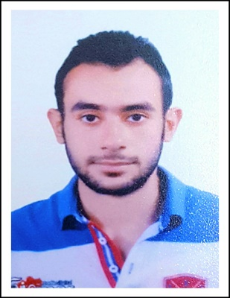**Name : Osama saied yousef Abd El-rahman .**

**Mobile No.:  01212325132 .  Date of birth: 05 FEB 1992 .   
Tel (home): 040-3508134 . Nationality: Egyptien .   
E-mail: osamasaied5000@gmail.com.  Marital Status: Single .**

**Military service : Finished**

**Address :  AL-GHARBIA-TANTA – tagneed area OF Tanta** .

**Educational Attainments : - Bachelor of Civil Engineering .** **-The project of graduation (FOUNDATIONS) grade EXELANT .**

**Graduated from : Misr Academy for Engineering & Technology (M.E.T ) at 2014 .**

**Experience:**

**-Worked at SAMCO company at the project of constructing defra bridge.**

**-worked at alsaad company for contracting and construction In the project the establishment of the Gates of the complex medical tanta University .**

**-The ability to receive reinforcement ,carpentry works and casting the concrete.**

**-perform c.f.a piles .**

**- Ready to work in any situation and under any pressure and responsibility** .

**- Successfully completed a traning courses entitled (SAP – SAFE – ETABS ) At faculty of Engineering Mansoura University .**

**OBJECTIVE:**  
**Seeking for a reputable job in the (civil engineering) field in a good company in which I can achieve my ambition and to be able to contribute into the development of the company and share knowledge and skills .**

**Languages :**

**- Arabic: Native .**  
**- English : Good (written & spoken)** .

**Computer skills :**

**- Knowledge of Microsoft Office – word – exel .**

**- Internet and e-mailing .**