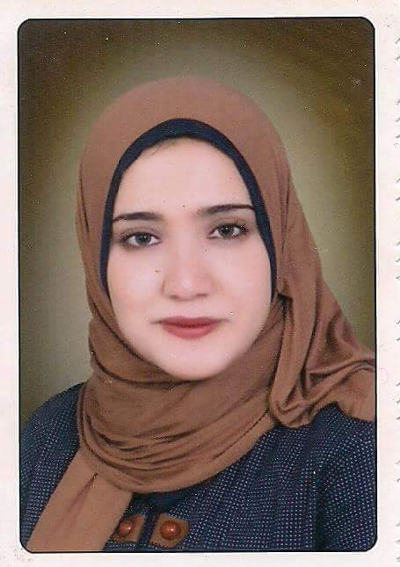**Name:** *NADA MOUSAD BERGALA*

**Mobile:** *01277738313*

[**Email/**nada.hazem8791@yahoo.co*m*](mailto:Email/rany201126@yahoo.com)

**Address:**  *el fatah street* – Gharbia – Egypt.

**Objectives:**

**Seeking the opportunity to work in your company, interact effectively with people as a team work focusing on achieving company goals & objectives.**

# Resume

|  |  |  |
| --- | --- | --- |
| *08/01/1991* | **:** | **Date of Birth** |
| **Egyptian** | **:** | **Nationality** |
| **married** | **:** | **Marital status** |
| **Without permit.** | **:** | **Driving license** |

**Personal Information:**

**Education:**

|  |  |  |
| --- | --- | --- |
| **Faculty of Engineering** | **:** | **Tanta University** |
| Civil Engineer 2014  **accepted** | **:** | **DEPARTMENT**  **GRADE** |

**Language skill:**

|  |
| --- |
| • Arabic : Native  **Very good: ENGLISH**  **GENERAL ENGLISH AND CONVERSATION** |

**Personal competencies in work:**

* **Excellent communication skills (verbal , written and listening).**
* **Strong people skills influencing and collaborative skills.**
* **Resourceful, able to dealing with pressure.**
* **Organization with the ability to set achieve desired results.**
* **High energy level and positive attitude.**

**Personal features :**

* **PUNCTUAL.**
* **ENERGETIC.**
* **HARD WORKER .**
* **WORK UNDER PRESSURE**
* **EFFICENT.**
* **PATIENT.**
* **LOVE MY JOB , IT GIVES SELF STEAM.**
* **SELF MOTIVATED.**
* **GOOD COMMUNICATION &LEADERSHIP SKILLS.**
* **COPE UP WITH NEW WORKS ROLES OR MISSION VARIBLES QUICKLY.**
* **MY ABILITY TO LEARN VERY FAST.**

***Experience:*** without

***Courses:*** design (sap & autocad )

**Finally:**I hope that my qualification and experience will meet your requirements and join your successful team.

***Thank you for taking the time to read letter and resume***

***References will be provided upon request***