|  |  |  |  |  |
| --- | --- | --- | --- | --- |
| **C.V** | | | | |
| **Personal Information** | | | | |
| **Sherif Ahmed Helmy Atef Elgendy** | | | **Name** | |
| **Egyptian** | | | **Nationality** | |
| **17/04/1985** | | | **Birth date** | |
| **Egypt** | | | **Birth place** | |
| **Single** | | | **Marital Status** | |
| **Permanently Exempt** | | | **Military** | |
| **Grade** | **Year** | **Major** | | **Education** |
| **Pass** | **2002-2006** | **Accounting** | | **Faculty Of Commerce / Tanta University** |
| **2016-Till Now** | | **Financial Accounting & Auditing** | | **Diploma At Faculty Of Commerce**  **Tanta University** |
| **Courses** | | | | |
| * **ICDL Certificates** | | | | |
| * **Levels 1, 2, 3 Conversation English Courses.** | | | | |
| * **Certificate of preparing accountants.** | | | | |
| * **Certificate of comprehensive accountant Diploma – C.G.A.A Of Professional Accountants.** | | | | |
| * **Certificate of accounting excel - C.G.A.A Of Professional Accountants.** | | | | |
| * **Certificate of passing taxes - C.G.A.A Of Professional Accountants.** | | | | |
| * **Certificate of passing in contracting Field - C.G.A.A Of Professional Accountants** | | | | |

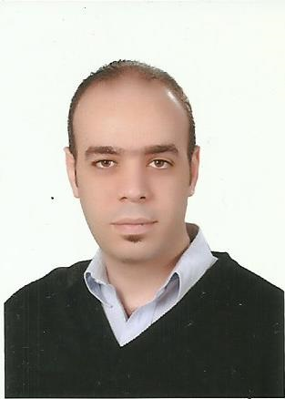

|  |
| --- |
| **Experience** |
| * **Worked At Faculty of Agriculture / Tanta University from 12/2008 to 07/2010.** |
| * **Worked for Alsefy co. for import and export as sales executive then as exporting manager from 1/2011 to 07/2013.** |
| * **Worked as an accountant for C.G.A.A Of Professional Accountants from 08/2013 till 07/2016.** |

|  |  |
| --- | --- |
| **Personal Skills** | |
| * **Ability to work in a group or individually according to the Condition.** | |
| * **Work Good Under Pressure.** | |
| * **Highly communication skills.** | |
| * **Interactive and fast enough to learn new things.** | |
| **Contact Information** | |
| **sherif_elgendy@ymail.com** | **E-mail** |
| **002-01289916023 / 002-01003407216** | **Mobile** |
| **Quhafa – Tanta - Algharbia - Egypt** | **Address** |