**Abdul-Aziz Elsayed Abouzeed**

**Personal Data:**

* 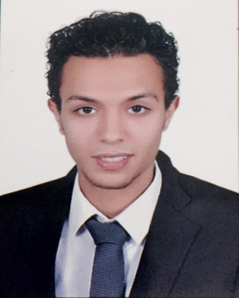
* Date of Birth: October, 01-10-1991.
* Place of Birth: Tanta, Gharbia , Egypt.
* Gender: Male.
* Marital Status: single.
* Nationality: Egyptian.
* Military Service: Served.
* Address: Tanta - Gharbia - Egypt.
* Cellular Phone: 01002991695
* Email: abdelazizabouzeed@gmail.com
* Email: abdelazizabouzeed@hotmail.com

**Objective:**

Ambitious Search for The Best Case and Wanted to Be One of Your Company Team, I Wanted to Apply My Skills and Abilities, Enhance My Knowledge and Experience and Create Effective Solving of Problems with Dealing Cooperatively with Others..

**Education:**

* B.Sc. In Mechanical Engineering 2014.
* Major Specialty: Power & Machines.
* University: Higher Institute Of Aviation Engineering and Technology.
* Graduation Project: Fire Tube Boiler Design.

**Grades:**

* General grade: Good by (65.6%).
* Graduation project: Very Good.
* MEMBERSHIPS: Egypt Syndicate of Engineers & Federation of Arab Engineers.

**Training:**

* **EGYCET:** (Training Course Certificate) 2016 in Firefighting Network, Pumps and Pump rooms.

**EGYCET**: (Training Course Certificate) 2016 in Central Air- Conditioning.

: Design All HVAC systems & Air Duct Sizing.

* **Petro jet:** (Project management and welding pipe) 2011.
* **EGYCET:** Internal Combustion Engines (Diesel & Petrol Engine) 2016.
* **CMB:** (Hydraulic & Pneumatic Systems) 2012.
* **Tanta Timber Company:**  (Fire & Oil Tube Boiler) 2013.
* **EGYCET** (Training Course) 2016 in Drainage &Water Feeding Systems.

**Courses:**

* AutoCAD **(Cairo University)** 2014.
* Autodesk MEP Revit **( EGYCET )** 2015.
* Fluid Mechanical Parts **(Faculty)** 2010.
* Duct size **(EGYCET)** 2016.
* Pipe seizer **(Serve Study)** 2016.
* Design all HVAC system **( EGYCET )** 2016.
* Design all Fire Fighting systems **( EGYCET )** 2016.
* Design all Drainage &water feeding system **( EGYCET )** 2016.

**Work Experience:**

* **October 2016 – Present**

**Executive and Designer Engineer:**

**Sama Miser Company - Egypt.**

* The design of all acts of MEP (air conditioning and firefighting and

Sewage and feed water and medical gases).

* Supervising the implementation of all acts of all types of air conditioning (central – chilled Water system - Dx – Split).
* Supervising the implementation of all the work related to the fight against the fire and also supervise the implementation of the pump rooms.
* Supervising the implementation of all sewage works and water and feed all acts of pumping stations.
* Supervising the implementation of all acts of lifts and electrical generators.

**March 2016 – October 2016**

**Mechanical Shift Engineer:**

**Reef Oasis – Sharm Al Sheikh .**

* Preventive Maintenance and Maintenance of Breakdowns of conditioning machines of all kinds as (central – chilled Water system - Dx – Split - Freezers).
* Maintenance of fire-fighting pump rooms & Domestic Pumps and Plumbing Systems.

**Computer Skills:**

* Windows applications & Office.
* Internet applications.
* Excellent using all programs which are used in design air conditioning.
* Excellent using all programs which are used in design air network.
* Very Good Using AutoCAD.
* Very Good Using hap program.
* Very Good Using Eelit firefighting program.
* Very Good Using Duct sizing and pipe sizing program.

**Languages:**

* Arabic : Native**.**
* English : Good spoken & written**.**

**References Furnished upon request.**