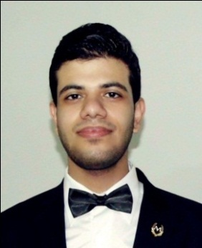 **Mahmoud Ibrahim Mohammed Ebeed**

**32 Ahmed Abd El-bar St. Tanta, Egypt Mobile No.: 01156789367/ 01013138618**

# Email: Mahmoud.ebeed7@gmail.com

# Fighter.abeed@yahoo.com

***Career Objective:***

**I am a fresh college graduate currently looking for a full-time** **accountant position to pursue a professional career and looking for work to expand my knowledge and experience where I can demonstrate my technical and business skills and Contribute to the company.**

***Educational Background:***

* **Bachelor of Commerce (Accounting Department).**
* **Tanta University.**
* **Grade Average at Graduation: Good.**
* **Graduation Year: 2015.**

***Training Courses:***

|  |  |
| --- | --- |
| * *Excellent with MS Office Applications* |  |
| - Word. - Excel.  - PowerPoint. - Access.  - Excellent in the internet APPs. |

* ***Certified Excel Accounting Specialist.***
* ***Cambridge Diploma in English Language (Started Recently)*.**
* ***Training in Accounting Office.***

***Career Progression- Employment History:***

* **Worked a Public Relations Representative at the Egyptian International Company for Tourism.**
* **Branch Accountant at Al-Jazeera Paints Store.**
* **Accountant at Baron Palace Resort Sahl Hasheesh 6 Stars Hotel, Hurghada.**

***Other Pertinent Information:***

|  |  |
| --- | --- |
| *Languages* | *Level of proficiency* |
| **Arabic** | **Native** |
| English | Excellent |

***Some features which I possess:***

* **Good presenter.**
* **Decision maker.**
* **Fast Learning.**
* **Active in a team work.**
* **Good communication skills.**
* **Dynamic, Creative and self-motivated.**
* **Highly efficiency in work under pressure.**
* **Very good problem solving skills.**

***Interests and hobbies:***

* **Reading adventure books and mystery.**
* **Watching documentary films.**
* **Travelling.**
* **Driving cars.**
* **Playing football.**

***Personal Data:***

* **Gender:Male.**
* **D.O.B.: May 07th, 1993.**
* **Nationality: Egyptian.**
* **Marital Status: Single.**
* **Military Status: Exempt.**
* **Driving-license: Available.**

**Sincerely,**

**M. Ibrahim …**