Curriculum vitae
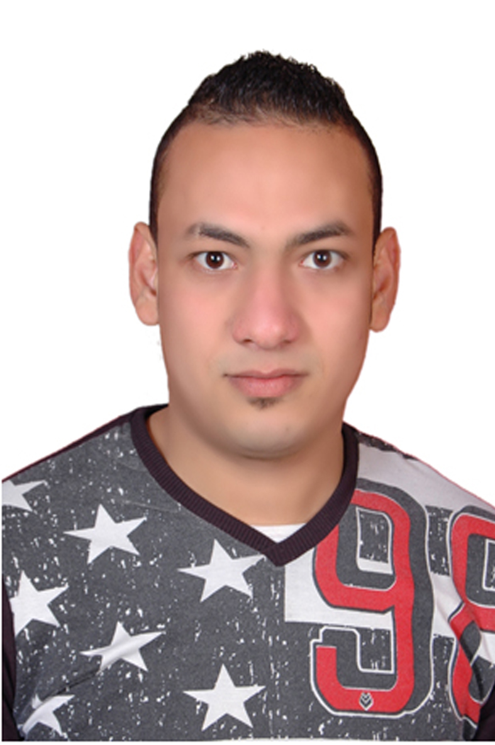
Name: Ahmed Hassan Ibrahem Elhalpy
Address: mohalet marhom .Tanta.
Date of birth: Jun,1 1993 Mobile No: (002) 01147475159
Nationality: egyptian
Maritary status: single
Religion: Muslim
Military status: finished
E-mail: ahmed.hassan2210@yahoo.com

Education:
Graduate of Social Work
Experience:
at L,imperatore restaurant in Hurghada
One way mall for mens wear in Tanta
Carina for woman wear in el Oroaba mall in tanta
Language skills:
1. Arabic : Mather tongue.
2. English : good (speaking,writing,listening,reading)
Computer skills:
1. office (word , excel)
2. internet explorer
Personal skills:
1. good communicating
2. able to work under pressure
3. able to do many works in the same time
4. able to lead a team with a family spirit way.

Thank you
Ahmed Hassan
Finally it gives me a great pleasure to work with your respectable team,in your esteemed company

