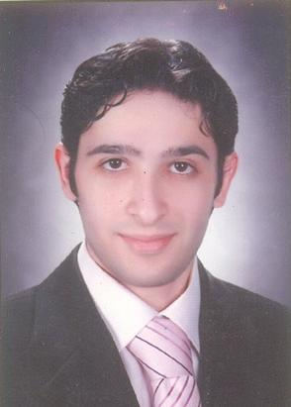  AhmaD Helal Saed  19 st. Osman abn afan,Tanta, Egypt  Cell +201 00 87 88 326  ahmadaziiz222@gmail.com  Education:  - L.L.B : Faculty of Law Tanta University , Egypt (2009)  - Master degree in Administrative law (2015)  Languages :  English (Good)  Arabic (Mother Tongue) | Experience :  - I had my own business but i shut it down because of financial problems (from September 2009 to April 2012 ).  - Internship at Hanan El Gewiny law office (from November 2012 to January 2013).  - I started my business again in dairy products ( 2014 : 2016 )  Personal Skills :  - Can lead teams and successfully handle team conflicts.  - Hard working, punctual energetic, self motivated.  - Can work under pressure and long hours.  - Able to learn new tasks quickly.  - Good presentation and public speaking skills.  - Ability to work in team or individually according to the task.  - Willing to work hard and learn more all over the way as i gain more experience.  Training Courses:  - NLP Certificate Signed By Dr.Ibrahim El Feki .  - ICDL (International computer driving license) and Internet Research Skills .  - Excellent Using ( WIN 7 – XP ).  - Excellent Using ( WIN VISTA ).  Objective :  - Finding a good Job Opportunity where my background, teamwork abilities and interpersonal skills can be used and developed.

