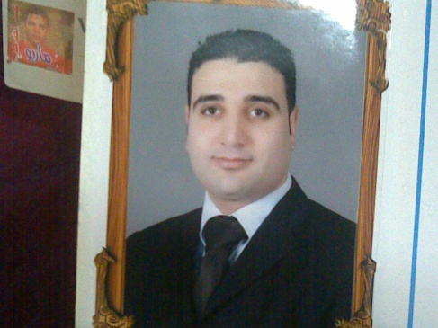 **Mohammed El Sawy Ahmed Mansor**

Alexzander ibrahim st- Miami sedi bisher -alexandria - egypt

Mobil num (010)07060109

**PERSONAL DATA:**

**Date of birth** : 14th September 1982.

**Marital status**  : married.

**Military service**: exempted.

**Nationality** : Egyptian.

**CAREER OBJECTIVE:**

Seeking a accounting position, that enables me to utilize communication, and

Language skills fulfill my personal ambition and enhance my knowledge.

**EDUCATION BACKGROUND:**

2004 Bachelor of Commerce- Mansora University.

Major: accounting department.

**EXTRA COURSES:**

* + Microsoft office (windows xp – word – excel – power point – access).

**LANGUAGE SKILLS:**

**Arabic:** mother tongue.

**English:**  good command spoken & written.

**WORK EXPERIENCE:**

* An accountant at Hamad commercial company.
* An accountant at Alla El Gebaly plastic factory.
* An accountant at Alixandria Company for chemical industry.
* Owner and manager of siper net Zoom cafe for computer & laptops & networks ( services and sales).
* A sales man & Technical support at EL SHAF3Y Company for computers & laptops.
* An accountant at Vision Company for trucks parts.
* An accountant at Egyled Company for exporting led screens.

**PERSONAL SKILLES:**

* 1. Strong interpersonal and communicative skills.
  2. Self- motivated and ambitious.
  3. Flexibility.
  4. Ability to work under stress.
  5. willingness to work on a shift basis according

Business requirement.

* 1. maintain a professional attitude with colleagues,

Supervisors and managers.