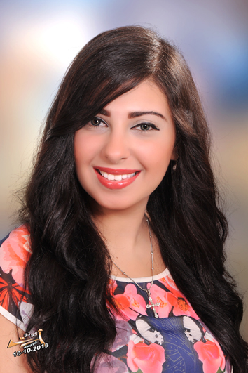
Caroline Adeb Tawfic

Mail: carolinadeb@gmail.com
Address: tanta _44 salim mousa st haron el rashed
Mobile: 01277447967
Date of Birth: 12 of February 1994
Marital Status: Single
Language: Arabic - Mother tongue
English Excellent read, write & speak

Profile
I believe I could add value to the company as i have a lot of experience in many categories, thus creating a win – win situation for both my employer and me.
I strongly trust that I am an asset for my employer.
Education
B.S., Faculty of law Tanta University 2015
Degree: good.
Training Certificates
English Course,
ICDL,
Personal Skills
• Active listener, Organized, Good planner and Take responsibility
• Ability to work under pressure
• Ability to deal with people effectively and politely
• Excellent in Services & Volunteer work
• Flexible and adaptable approach to work.
• Quick learner

It is a great pleasure for me to join your team work and
I hope that my C.V. will fulfill your requirements.

