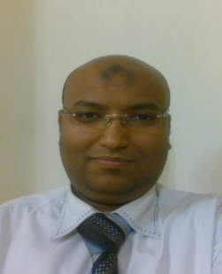**Mohamed Ahmed Abd Elshafy Mohammed**

**Egypt - Giza – ismaeel el gendy St.No.13**

**Tel.No :**

**Home : 202-37776391**

**Mobile : 010-66643341**

**E-Mail**:

**Mahamed.abdelshafy@yahoo.com**

**Personal details:**

**Nationality    : Egyptian   
 Religion         : Muslim  
 Date of Birth : 07/02/1980      
 Education     :license from faculty of law (Cairo university2000)  
 Grade            : pass  
 Status of Military service : exempted  
Marital status : single**

**Objective**

**To work at professional field (marketing & sales manager) Administration Career it’s my best field which to require how to make variant plans to (marketing, sales; planning area for advertising, target's achievement s…etc.)**

**computer skills**

|  |  |  |  |  |
| --- | --- | --- | --- | --- |
| **Inter net** | **MS - excel** | **MS - word** | **Windows** | **Subject** |
| **excellent** | **excellent** | **excellent** | **excellent** | **Skill level** |

**Work experience :**

**-1997-2000 : Regina style village as sales time share sell projects in hughada & sharm el shekh .**

**- 2000-2002 : Golden Five City Legal Officer timeshare we sell projects in hurghada .**

**-2002-2005 : JETECOfor Tourism Development & Building as Legal Officer Head in zaafarana resort .**

**-2005-2006 : Bharaonic AmericanLife Insurance Co &Noorseen integrated insurance service Co as Legal affairs section Head**

**-2006- 2008 : Khobaraafor real estate development & investment co as Legal affairs section Head at projects in 6october city ( la city ) .**

**-2008-2010 : Alfursanfor real estate development & investment as Legal affairs section Head as projects in the Fifth Avenue in New Cairo(One piece) & el Ain Sukhna(Bella Vista Village) & subra &October gardens(el rbab) &misr el gededa (Heliopolis rock) .**

**-2010-2011 : City hieghts for real estate & urban development as Legal affairs section Head we sell projects in obour city( city hieghts mall ).**

**- 2011-2013 : Mimarfor real estate development & investment as Legal affairs manager part time we sell projects in 6october city (la maison mall ).**

**- 2014-2016 now :Darakfor for real estate development & investment as Legal affairs manager at projects in (ahram gardens) & (el shekh zaid Buildings) .**

**Hobbies:**

**I take any active hobbies (Computer-Internet-     
Reading –Enjoy swimming-football-driving cars)**