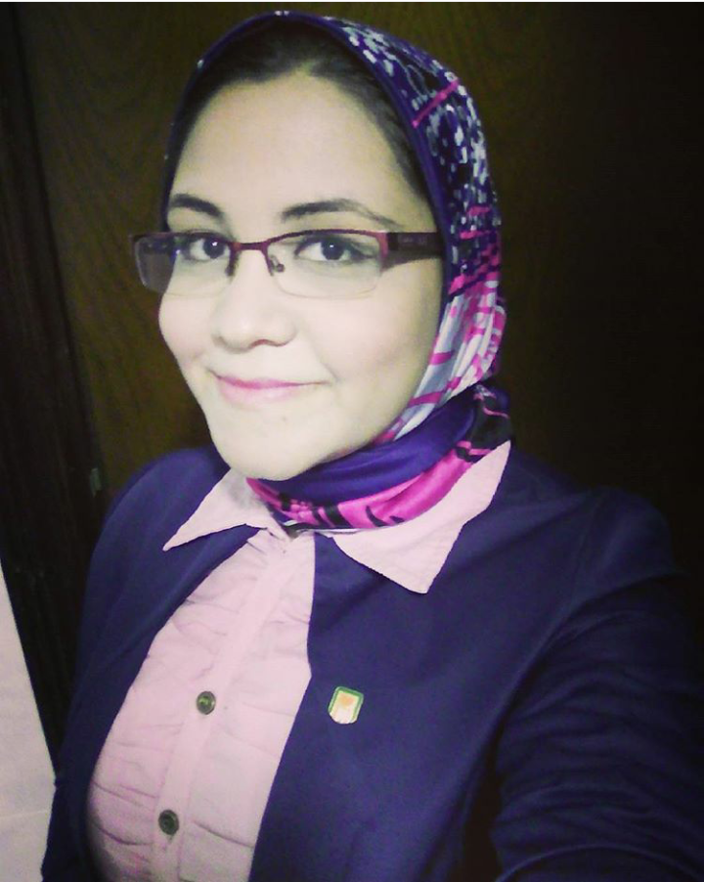
Cv
personal data

Name: reham ayman elsayd gomaa
Date of birthe: 27/9/1991
Adress: Cairo,maadi

Nationality: egyption
Marital status: single
Emal adress: rawraw.m9@gmail.com
Mobile: 01093060169
Mobile: 01158815242

Education
2012, tanta university, faculty of commerce english sectin
Qualified in : business administration

Personal skills
Computer skills : word, excel, MC office
Languages: arabic, english
Career interests: marketing , customer services, sales
Others skills
Teamwork oriente
Dability to work flexible hours

courses

english , computer, HR
experience
1- customer service and sales in national bank of egypt(out source company) for 2 years

