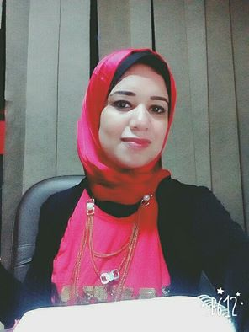

**Sally MostafaRefai**

**Mobile:**01010689166

**E-mail:**[sally_mostafa612@Yahoo.com](mailto:sally_mostafa612@Yahoo.com)

**Address :**Ali mobarkSt, –Tanta , Egypt

**OBJECTIVE:_**

I wish to work out what I've learned using my talent, hard working, creativity & the ability to work in group with the team spirit to achieve our organization goals. Self-motivated, work under pressure excellent communications skills, manage stress quick learner, flexible in approach with a positiveattitude.

**ADDITIONAL INFORMATION**

* **Nationality:** Egyptian.
* **Birth Date:** 6thDec 1987.
* **Marital Status:** Single.
* **Languages:**

Arabic Native Language**.**

* + English Good Spoken and Very Good written & Reading.

**EDUCATION**

**[Tanta University]**

* Faculty Of Education, Tanta University .
* B.Sc.of Education, English section. 2009.
* Grade**:**Good.



**CERTIFICATES**

* + Microsoft Certificates.
* Microsoft .Net Framework 3.5 Window Application .
* Microsoft Web Application Technologies with Microsoft Visual Studio 2005 .
* Microsoft Foundations of Microsoft .NET 2.0 Development .
* Microsoft Data Access with Microsoft Visual Studio 2005.
* Microsoft Advanced Windows Forms Technologies with Microsoft Visual Studio 2005
  + ICDL (International Computer driving Licenses).
  + TOEFL

**Work & Training Experience:**

**\*Working as Executive secretaryat Arab lifts companyFrom2014 till now**

**\*Worked as sales at Dream Town company**

**\*Worked as customer service& Receptionist at Yasmina Plaza Village.**

**\*Worked as an English teacherat Anglo American center**

**Programming Languages**

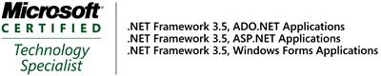

* Visual Studio 2008.
* ASP.Net.
* ADO.Net.

**Database Management Systems DBMS**

* Microsoft SQL Server2005, 2008.
* Microsoft Access.

**Operating Systems**

* WindowsXP.
* Windows 7 .

**Productivity Suites**

* Microsoft Office XP, 2003, 2007.

**PERSONAL SKILLS**

* Eager to learn.
* Innovation in work.
* Advanced research capabilities.
* High Communications skills.
* Self-motivated and Ambitious.
* Hard worker and can work under pressure.
* Interactive and fast enough to learn new technologies and tools.
* Ability to work in a team or individually according to the job requirements.
* Good in Internet follow up and updating myself.
* Ability to know people easily and gain their friendship and Confidence.

**Soft Skills**:Courses In:

* Problem solving and decision making.
* Team Building and Leadership Management.
* Customer Service Skills.
* Human Resource Course**.**
* Organizational behavior.
* Business Technical Writing.
* Presentation &Communication.

**References:**

* **Available with all their details upon your respected request.**

**(Thanks a lot for looking into my C.V.**