Madona Rafiek Kamel Habib
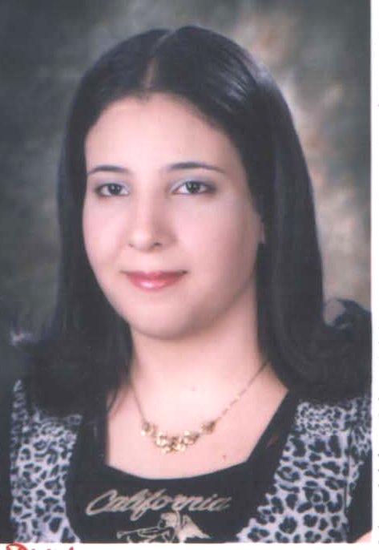
Mobile : (+20) 1202825480
: (+20) 1285745808
: (+20) 1001878857
Home phone : (+20) 403411422
Date of Birth : 24 July 1991
Nationality : Egyptian
Marital Status : Single
Address : 10 EL-Batraweshy Street- Tanta - Egypt
E-mail : Madona.Rafiek@yahoo.com

OBJECTIVES :

Seeking to be a part of the working group at a challenging position, doing my best effort and work hard within the organization to be better and even better in the future.

EXPERIENCE:

- Office Manager at Mega Tours Travel agency for domistic and international tourism from 06 \ 2016 till now
- responsible for booking of the hotels and transportation tickets
- responsible for receiving the cash amount of the booking.
- responsible of the weekly bank deposit
- responsible for the miscellaneous expenses.

- Front office secretary at Nagham Music center from 02 \ 2015 til 05 \ 2015
- responsible for reservation of the new courses
- organizing the courses schedules

- Tele-Sales indoor at pan de vie compny for security and companies office supplies from 11 \ 2012 till 01\2013
- responsible for marketing company services to targeted customers
- explaining the technical specifications of the devices

EDUCATION :

- Bachelor degree of commerce 2012
- English section, Accounting department
- Tanta University, Egypt
- Grade: Good

Skills & Qualifications:

- Language skills:
- Arabic: Mother Tongue
- English: Excellent in spoken, written and reading

- Computer skills:
- Microsoft Office Package: Excel, Word, PowerPoint, Access and Outlook Express
Courses:

- December 2012 Obtained ICDL Certificate
- August 2012 Business English Courses & Soft Skills
At New Horizons (EDUE Egypt Courses)

Personal Skills:

- Ability to work individually.
- Being able to work in a team.
- Being able to work under pressure.
- Having the ability to learn fast and apply new skills.
- Self motivation and very ambitious.
- Well organized.

References:

Should you require any references; all references will be furnished upon request.

