PERSONAL INFORMATION | Halla Mohamed Ahmed Mohamed
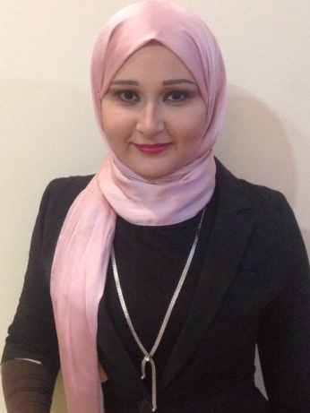 | 34, abd elhamed ragb st, azbet khder, Mahalla, 31811, Egypt.
 | +20 40 2405741 +02 01110451172
 | Lollynada99@gmail.com
 | SexFemale | Date of birth16 November 1992| NationalityEgyptian

WORK EXPERIENCE

2017-present  September2016-dec | Sales team at AMLLAK for real estate development at Palm Quarter in El-mahalla
 | -TeDate costumer serves for 4 month

EDUCATION AND TRAINING

2012 – 2016 | Faculty of commerce at Tanta university  Accounting

PERSONAL SKILLS

Mother tongue(s) | Arabic
Other language(s) | UNDERSTANDING |  | SPEAKING |  | WRITING
 | Listening | Reading | Spoken interaction | Spoken production
English | B 2 | B 2 | B 2 | B 1 | B 2
 | Through Completing my studies in English, general course in English and conversation level 6 course.
Levels: A1/2: Basic user - B1/2: Independent user - C1/2 Proficient user
Common European Framework of Reference for Languages

Communication skills | -Team work : worked in different kind of teams like research teams, participated with many different groups for , beside my experience in being a group leader during my bachelor study

Organisational / managerial skills | -organizing and participating in spatial events and workshops to help our research goals
Job-related skills | -Able to work in a group or individually with the same quality also can work under strict deadlines, good presentation skills (participated in presenting projects in seminars)

Computer skills | -good command of Microsoft Office™ tools since 2010  -ICDL[National Technology Center ] | [TANTA]

Other skills | visiting museums and art galleries, doing voluntary work, reading about different cultures, visiting new places

ADDITIONAL INFORMATION

Presentations  Conferences  Seminars  & competitions  Memberships | -participated in a sale carnival of Palm Quarter and Porto Group at the project site  Attended many different events in different fields like culture events and book signing and organizing a felid trips and participating in voluntary campaigns for Resala and Sonaa elhayah  Member in Resalla and a former member in the student union at collage

ANNEXES

- copies of degrees and qualifications;
- Publications or research.

