Ahmed Ibrahim Zaky Abo-El Dahab

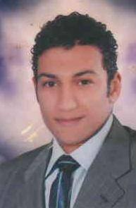Address: 26 El Shaikha Sabah St, Tanta.

Mobile: +2 0128 554 4608 _ 01011002308

Email: [Ahmedaboeldahab4@gmail.com](mailto:Ahmedaboeldahab4@gmail.com)

Date of birth: 19-11-1989

Marital Status: Single

Military Status: Exempted

Nationality: Egyptian

Education And Qualifications

* **B**.ScDegree, Faculty of Law, Tanta University.
* Graduation Year: 2011

Relevant Experience and Achievement

* Customer service representative at Vodafone Egypt from 1 / 2016 till now.
* Public relation coordinator in Misr Foods from 1 / 2015 to 1 / 2016.

|  |
| --- |
| * Legal Affairs at Association of Community Development and Small Projects   ( Al-Mobadra ) From 7 / 2012 to 1 / 2015.  Courses and Trainings :   * English course at Nobel Academy, Tanta, 2012. * ICDL "Ms Office".   Computer and Language Skills :     * Windows and Internet ( Expert user) * Word - Excel - Power point -Access (very good) * Arabic - Native * English - average |

Certificates

* English certificate from Nobel Academy.
* International Computer Driving License (ICDL).

Skills:

* Interpersonal Communication Skills.
* Customer Service Skills.
* Work under stress.
* Inspired by team work.

**For further References are available upon request**