Curriculum vitae
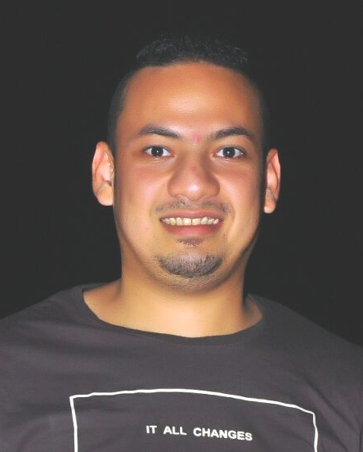
Name: Ahmed Hassan Ibrahem Elhalpy
Address: mohalet marhom .Tanta.
Date of birth: Jun,1 1993 Mobile No: (002) 01147475159
Nationality: Egyptian
Maritary status: Single
Religion: Muslim
Military status: Finished
E-mail: ahmed.hassan2210@yahoo.com
Education:
Graduate of Social Work
Experience:
at L,imperatore restaurant in Hurghada
One way mall for mens wear in Tanta
Carina for woman wear in el Oroaba mall in tanta
townteam for men,s wear in tanta until now
Language skills:
1. Arabic : Mather tongue.
2. English : good (speaking,writing,listening,reading)
Computer skills:
1. office (word , excel)
2. internet explorer
Personal skills:
1. good communicating
2. able to work under pressure
3. able to do many works in the same time
4. able to lead a team with a family spirit way.

Thank you
Ahmed Hassan
Finally it gives me a great pleasure to work with your respectable team,in your esteemed company

