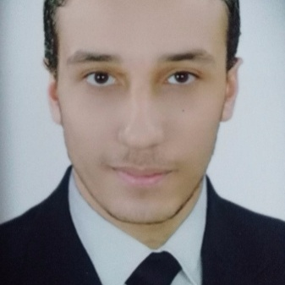 | Emad Mohamedi Fawzy Habib  Address: El Helw st, from al-Gala  Tanta, gharbia, Egypt.  Tel: +201281857203  E- mail: emad.habib.pro@gmail.com

PERSONAL DATA  education  skills  WORKING EXPERIENCE | Date of birth : 9th April 1992 .  Nationality : Egyptian.  Marital Status : Single.  Military Status : Exempt .  Driving license : Available .  - Personal skills  - Excellent Communication and Interpersonal skills.  - Excellent Presentation skills.  - Self motivated , challenger , interactive.  - Fast enough to learn new technology and science.  - Ability to work in group or individual.  - Working under stress.  - Language skills  Arabic : Mother tongue English : good (Spoken & Written)  - Computer Skills  - Excellent tknowledge about MS operating systems.  - Excellent in using Microsoft Applications 2003, 2007 ( word , excel ).  - Excellent in using the internet and web applications.  - Excellent in using VisualStudio , Eclipse , SQL Server.  - HTML , XML , Java , c# .  - Personal Interests  - Technology  - IT & Network  - Computer Science  - Training at Rendering Legal Office from May 2016 up to Dec 2016.  - Working in the Zakaa Company Administrative Assistant from Jan 2016 up to March 2016.  - Working in the Freelnacer Software Developer from Jan 2013 up to Oct 2015.  - Working in the Court Lawyer from Jan 2017 up to June 2017.
  B.Sc. in Law. Oct, 2015
  Faculty of law Tanta University
  Tanta, gharbia..

