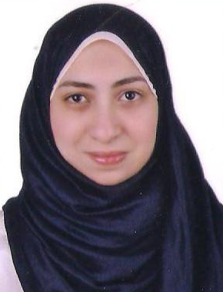
References

E-mail: mahasamir43@gmail.com

Mobile: 01011359976--01069359779

Maha Samir Taha Yasin

Personal Information:

- Marital status : Single
- Nationality : Egyptian
- Date of Birth : 5^{h} of october, 1990

- Working as Customer Experience Expert at VFS Tasheel International from January, 5 - 2014 till August 2017 specializes in managing and administrating the Visa Application and Issuance process on behalf of the Kingdom of Saudi Arabia.
- Handle queries and ensuring accurate information is given to the customer about the services and upsell value added services.
- Accurate data check and entry of documents and records.
- Adhere to the standard operating procedures.
- Ensure adherence to the process in order to reduce the number of reprocesses.
- Accuracy and quality of the application.
- Maintain customer satisfaction.
- Official complains officer of Tanta Branch
- Handling Mailbox statistics, Feedbacks and analysis for Tanta branch.
- In charge of Info fort Account for Tanta branch.


Objective

Dedicated and Hardworking professional with proven abilities in Administrative & Customer Service.
Quick learner having strong public relation and customer service skills, ability to interact with cross-functional departments, with high degree of professionalism, discretion and problem resolution capabilities. Team-player, critical thinker, effective planner, along with excellent communication, self-correspondence and interpersonal skills

Education:

- Bachelor holder in Commerce, English section.
- Major: Accounting
- Tanta University.
- May, 2012.

Linguistics Skills:

Consequently, the following table illustrates my languages levels:-
Language | Reading | Written | Spoken
Arabic | Excellent | Excellent | Excellent
English | Excellent | Excellent | Very good

Professional Certification

- English conversation Certified at AAST IN ALEX(Arab Academy for Science Technology & Maritime Transport)
- I.C.D.L, from UNESCO certified at TANTA UNVERSITY
- Soft skills certified at New Horizons & HR department (Vasco World Wide)
- Personal leadership certified at (Vasco World Wide)
- Time management certified at (Vasco World Wide)
- customer service certified at (Vasco World Wide)
- communication skills certified at (Vasco World Wide)

Computer Skills:

- ICDL.
- Proficient with Ms Office package (MS Word/Ms Excel/Ms Power point).
- Dealt &exchanged data over networks (internet).
- Fast Typing.
- Dealt with troubleshoots and errors.
- Electronic queue management systems (EQMS)
Highlights of Qualifications:

- Ambitious, self motivated, direct and communicative.
- Committed, honest, reliable, energetic and hard worker.
- Ability to make quick and accurate decision
- High ability of convincing people.
- Ability to work under pressure.
- Eager to learn and enhance my personal knowledge through reading and social relations.

Awards
- Nominated for the category live the value (Nov 2014)
- Employee of the Month (Mar 2015)
- Nominated for the category of excellence (Jun 2015)
- Nominated for the category of excellence (Jun 2015)
- Nominated for the category of team spirit (Jun 2016)
- Nominated for the category of excellence (Jan 2016)

