CV

Personal Information
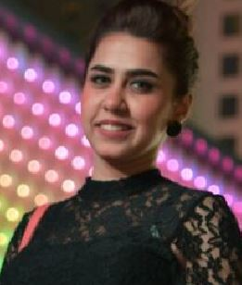

Name: Aya khalel Ibraheem alrubiay
Birth place: Iraq, Baghdad, District, alsaydea
Marital status: Single.
Accommodation: Baghdad
Telephone: 07704203523
Mail: aaya_ayoo@yahoo.com

Qualifications

Academic qualification:
Graduate from AL_mustansriyah University College of Education /
Computer Sciences/ Morning study / Year 2014 – 2015 (BA)

- Language , Professional Skills
Languages: Arabic , and English
- English - ( reading - very good / writing - very good / conversation - good)
- printing programs (Word, Power point, Excel,Access, Notepad
HTML, Photoshop
- creativity in the leadership of both Computer and Internet usage and solving problems related to them
- Web design
- Also flying system (saber).
- 2 Years Experience in the field of tourism and Perfect knowledge
Experience in marketing and sales management in the NASA Company for issue the tkt.
- I got (course for the aviation system and public relations in aviation collage in Dubai united Arab emirates
- I got 14 certificate in ( Emirates Skywards – Driving Loyalty . Emirates Arabic Cuisine . Live Animal Regulations . Accepting Passengers: Interline Electronic Tickets . Najm .

- SOAR - Service Over and Above the Rest [Retail Office] ,

- And last one is connect essential .

- I got also a certificate from Cambridge Institute for learning English.

Current Job: Emirates airline

