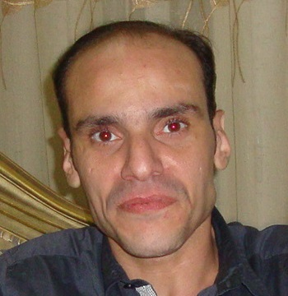

**C.V**

Accounting and Marketing Business

Ahmed Mustafa El - Greatly

Mobile: 002 - 01280330266

E-mail: [ahmedelgreatly@live.com](mailto:ahmedelgreatly@live.com)

Address: E. S. C

* **10 years experience in customer service , sales,  
   marketing business and Public Relations**

**in E.S.C & GCC**

* **Personal Information:**
* Date of Birth: 24th of September, 1981.
* Nationality: Egyptian.
* Gender: Male.
* Marital Status: Married.
* Military Status: Postponed.
* Driving license: Egyptian.
* **Education Information:**
* University Degree: Faculty of Commerce, accounting.
* University: Tanta University.
* Graduation Year: 2006.
* Grade: Accepted.
* Holds a certificate of elementary, junior high and high schools  
  of the State of Qatar from 1981 to the period 1999.

**Good reader wrote to human development and lectured conferences of Dr. Ibrahim Al-Fake God's mercy  
 and Dr. Tariq Sweden**

**This area is at the heart of a specialist in marketing and sales, public relations and customer service**

**I am fully aware of human development and I hope and I am honored to work with you to under one roof as a team work**

* **Career Objective:**

I'm a hardworking person and I’m so interested in finding  
a challenging job where I can make use of my personal talents as well as my scientific knowledge.

* **Courses :**
* Word, Excel.
* English General "Pre-Intermediate "

Certificate Enterprise sales academy modules & Customer Care Training supervisor from **‘’ Vodafone Qatar ‘’**

* **Skills :**
* **Languages**
* Arabic: Mother Tongue.
* English: V. Good speaking, reading & written.
* **Computer**
* Microsoft Windows 98, Me, XP & Vista.
* Microsoft Office.
* Adobe Photoshop.
* Internet Applications.
* Fully ready for use and learn any new programs.

**Work places**

* **AL MAKAREM travel Company (Manager)**

**FROM 01_06_2011 TO 01_02_2012**

Director of Religious Tourism and General Manager of Marketing  and Public Relation

* **ALMAKAREM IMPORT & EXPORT (Manager)**

**FROM 01_03_2012 TO 01_03_2013**

General manager of Marketing and fully responsible of the customers aboard.

* **Al JAIDAH automotive QATAR**

**FROM 01_04_2013 TO 30_03_2015**

Sales manager in retail department and are fully responsible for the customers

* **Vodafone Qatar Company**

**FROM 01-04-2015 TO 30-05-2017**

Enterprise Sales Manager In public sector

**Experiences**

* **Official and Supervisor production :**

Control product of any kind with the control and quality  
of manufacturing steps

In terms of manufacturing and raw color and degree of efficiency  
and control of pre- sales

* **Official and Supervisor Marketing :**

Determine the quality of the product of any kind and distribution of samples mint to places that could benefit from them in terms of marketing and websites that benefit from selling the product and preferred sites "corporate"

That is studied on the basis of the sale of the product, whether inside or outside companies to provide the greatest republic the potential gains and avoid losses as much as possible..

* **Honourable and responsible for customer service**

**And public relations:**

Meet customer needs and to explain the required information on the product and motivate them to benefits and privileges and usage requirements..

**Dear Sir/G.M**

**Human Resources Department:**

My enclosed CV shows that my background, education and experience match your needs as I have more than 8 years’ experience in the accounting and marketing businessfield and a degree in B.S in Egypt & GCC.,

I would like to arrange an interview with you to discuss my qualifications and your requirements further I am available for an interview at your convenience.

Thank you for your time and consideration.

Sincerely,

**Ahmed El-Greatly**