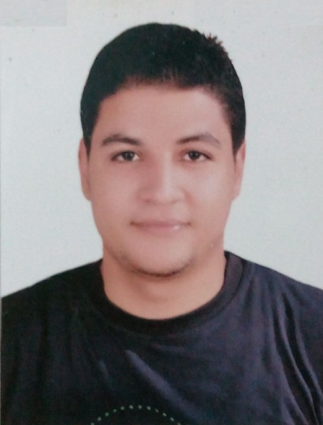**Ahmed Magdy Sayed Ali**

**67 – Ali Allamy street – Egypt – Tanta**

**002-012-0430-3230**

[**ahmedmagdi313@hotmail.com**](mailto:ahmedmagdi313@hotmail.com)

**Personal Information**

**Date of birth : 22/11/1992**

**Place of birth : Egypt-Tanta**

**Social status : Single**

**Religion : Muslim**

**Military Status : completed**

**\* Seeking a Bank Teller Or Customer Service position with YOUR COMPANY Bank using exceptional numerical skills and customer service orientation in order to provide a complete banking experience to the customers.**

**\* Hardworking professional seeking a position as a Bank Teller with YOUR COMPANY .**

**\* Offering profound ability to anticipate customer questions and provide ash services in a friendly and professional manner.**

**\* Answering basic customer questions regarding interest rates and the banks services**

**\* Transferring large and small funds from one customers account to another.**

**Education**

**\* Bachelor of Arts and Education . Tanta University**

**\* Department of English Language**

**\* Teaching with Techonology training course (online)**

**\* Graduation Year 2015**

**\* Grade Average ( pass )**

**Language Skills**

**- Arabic : native**

**- English : Excellent , Fluent.**

**Key Skills and Competencies**

**\* Excellent English speaker and writer ( keyboard ) * Cash handling .**

**\* Cash management *Data entry**

**\*Reporting any suspicious customer activity to bank managers & relevant colleagues.**

**\*Can quickly become familiar with all of a bank’s products and services.**

**\* Very good with Microsoft Office with ICDL certificate.**

**\*Excellent communication and negotiation skills.**

**\* Ability to work under pressure for extended hours.**

**\*Can communicate effectively and professionally with members of the public.**

**\*Able to speak in a relaxed and sociable manner to customers from all walks of life.**

**Experience**

**\* ICDL course certificate . *practicing the language in online paid courses .**

**\* working in a private job as a sales man and customer support in Original Company for phones software**

**\* one year experience working in the army as an information analyzer in the Special Forces headquarters Operations branch which involves with military cooperation practicing the language as a translator .**