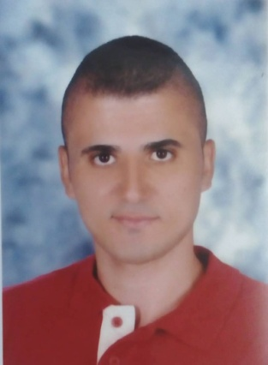
Mohamed Tarek Nasr El-Fakharany
Address: Tanta, Gharbia, Egypt
Tel: 01128379964
Email:mohamedelfakharany995@Yahoo.com

Education :
- Faculty of computers and information– department of information technology _ Menoufia university
- network engineer (may 2016)
-Graduation project: building detection by using sift detector and descriptor (image processing "Matlab")
- Project degree: Excellent
Experience
- Training at telecom Egypt in Tanta.
- training as it engineer in it unit at faculty of computers and information _ menoufia university for a month
- ccna academy from faculty of computers and information
Personal information:
Date of birth: 20 /2/1994 (23 years )
Marital status: (single)
Military service: Exempted

Skills:
Languages:
English: good ( writting & speaking )
Arabic: mother tongue

Computer:

- Good knowledge of the programs
- Proeficiency in windows programs and Microsoft.
Other skills:
- Ability to work both in team and individually.
- Ability to work under pressure.
- Accelerated learning.
- Presentation skills.
- Creative think and critical thinking.

It gives me a great pleasure to join your steamed team work and under your supervision

Signature
Mohamed Tarek

