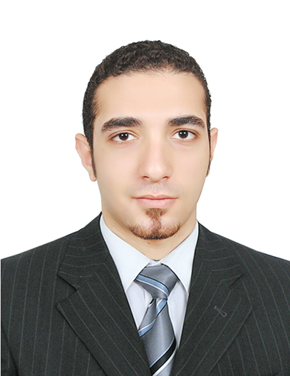
Personal Data:

Name : Ahmed Mohamed shawky Moubark
Date of Birth : 15/3/1993
Place of Birth : Albatanoun/Shebin Al-kom/Almenofia
The military status : Exempted
Home no : 048-2366460
Mobile no : 01093932816
Address : Abu saleh street/Albatanoun/Shebin Alkom/Al-menofia
Email : Ahmedmoubark4@gmail.com

Education Data:

Academic certification : B.Sc. Of Commerce /Accounting Department
University : Menofia University
Year of Graduation : 2013
General Grade : Good

Language Abilities:

Arabic : Mother tongue
English : Good (writing, Reading, Conversation).
Computer Skills:

Woked on many accounts software beside the Data entry
High experience of using Microsoft office package and
Windows operating system and internet
ICDL Certificate
The previous experiences:

Work as an accountant&marketing specialist for four years
Passed the Intensive Course in Electronic Accounting Peachtree&Accounting Application using Excel-Quick Books&Microsoft accounting Programs
Certificate of Human resource (HR) course
Got advanced english course
From Ministry of defence language institute (MODLI)

Further Feature:

Ability to create or learn advanced techniques related to my work. Ability to work under stress and work in teams
Ability to be a leadership and Good at communication skill

