C.v
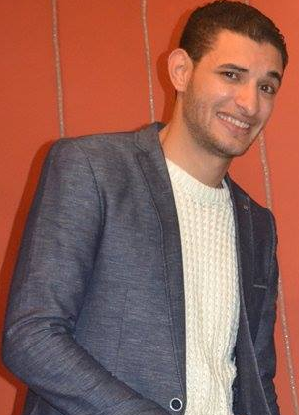

Personal data:-

Name:- mostafa abduala mostafa shalaby
Date of birth:-20/10/1990
Religion:-muslim
Nationality:-egyptian
Adreess:- hassen shehata .st from el rafaay .st tanta . el garbyaa
Tel:- 0403327624 Mobile Number:- 01011112721

Education:-
graduated from the Faculty of Law *
Tanta University 2011 *
Pass*

Work experience:-
Excellent for driver confidence and apply for test at any time and any place
*I worked in el Hefny company Contracting petroleum. Driver Heavy Equipment "crane"
*I worked in the trade of cars for a long time. And I have more Experience in cars and cars Accidents
* custmer service. Call Center agents in Etisalat Egypt company out soursing raya company from 2015 , and I support the new cameras.
* Now custmer servisen in elmasria auto
* And look forward to working for you and I hope good future for you and me

computer skills:-
*multimedia applicatons " very good in computer Software and Hardware
*Microsoft office "2003-2007-2010
*programming languages knoeledge java

high lights of qualification:-
*excellent presentation. Negotaton and interpersonal communication skils
*ability to set and achieve goals and work under pressure
*sense pf responsibility and a hard worker
*aself motivated team player with confience and commitment
* Ability to work indoor and outdoor
* Ability to work in a rapidly growing, fast-paced, intcractive, results –based environment
* Accurate and creatively
and I want to be achiever all the time *

Family information
Dad: He worked in the General Authority for Health Insurance (Head of Engineering Department) and now he is dead
Mom: customer service works Telecom Egypt since 36 years
Brother: Works Civil Engineer, Saudi Arabia

Looking forward:-
*my really wish invent a new car version
Access to higher grades and a better future*
*traveling and knowing different cultyres, reading, swimming
And i hope to be in good position in the future*

