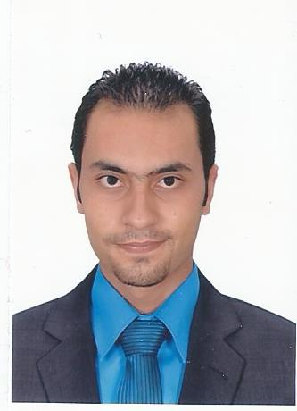**Name:** Ahmed Reda Mohamed Kandel.

**Address:** 2 Abdullah Ibn Masood St, Shibin ElKom, Egypt

**Mobile:** +20 100 816 4554.

**Email:** [**mrahmedkandel@gmail.com**](mailto:mrahmedkandel@gmail.com) **.**

**Career Objective:**

I'm seeking a challenging opportunity, promising career at a multinational organization that can help me enhancing my skills, applying my personal capabilities in Sales related fields.

**Personal Data:**

|  |  |  |
| --- | --- | --- |
| **Birth Date** | **:** | 23-11-1990**.** |
| **Gender** | **:** | Male. |
| **Marital status** | **:** | Married. |
| **Nationality** | **:** | Egyptian. |

|  |  |  |
| --- | --- | --- |
| **Military Status** | **:** | Final Exempted |

**Education:**

B.Sc. of Commerce at Minufiya University,

**Major:** Accounting,

**Class*:*** May 2012.

**Grade of Graduation:** Good.

**Work experience:**

* A Retail Sales at **"Orbit Company For Computer Hardware & Software in Egypt"**, Jan 2006 - Jan 2009.
* A Retail Sales Supervisor at **"VIP For Mobile Service in Egypt"**, September 2009 - September 2010.
* A Key Account Specialist at **"Saif El Watan Company in Saudi Arabia"**, December 2012 - May 2013.
* A Retail Sales Supervisor at **"S2 Telecom Company in Saudi Arabia"**, August 2013 – August 2015.
* A Product Specialist at **"AMS Company For Medical Services in Saudi Arabia"** August 2015 – Oct 2016.

**Training:**

* Two month training as A Telesales & Customer Service at **"Omneyat Company For International Calls in Egypt"**.
* Two month training as A Customer Service at **"Vodafone Corporation in Egypt"**.
* Three month training as Telesales at **"Ibn Sina Pharma Company in Egypt"**.

**Postgraduate Studies:**

**1. Completed Courses:**

1. **Human Development, Sales, Marketing, Customer Service and Business Administration (Intensive Course).**
2. **ICDL.**

**Language Skills:**

**Arabic:** Native language.

**English:** a very good command of English.

**Computer skills:**

1. **Excellent Command of:**

* Networking-Troubleshooting.
* PC Maintenance.
* (M.S) Office Package Programs.
* Windows Operating system (Installing & configuring Windows XP &Windows 7&Windows 8 ).

**Personal Skills:**

Hard worker, Energetic, Self-motivated, Good team player, Ambitious, dedicated, proactive, result oriented, work with minimal supervision, excellent communicator, able to learn new technologies and sciences, able to work under pressure and meet the dead lines.

**Work Skills:**

* Commercial Awareness.
* Communication.
* Team Work.
* Negotiation.
* Problem Solving.
* Leadership.
* Ability to work under pressure.
* Confidence.

**Interests:**

* Reading.
* Sports.
* Internet.
* Travelling.
* Technology.

**Great Honor To Be A Member in Your Teamwork.**