Abdelfattah waheed | 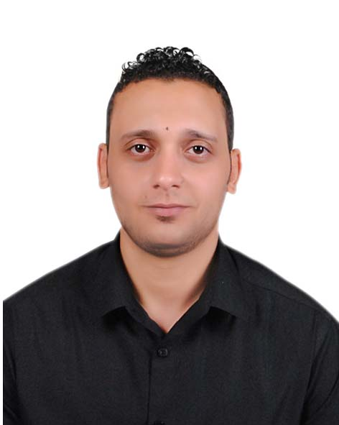
Address: tanta egypt
Mobile No : +201276342877

Email: fabrymix888@gmail.com

Objective:
Seeking a challenging position in a reputable company where my academic background and interpersonal skills are well developed and utilized.

Personal Information
Gender: | Male
Date of Birth: | 8/3/1990
Nationality: | Egyptian
Marital Status:  Military Service:  ) | Single  Exemption

Education
University Degree: | BA agriculture
University: | Alazhar university
Faculty: | Agriculture
Major: | Media Department (Puplic Relations)
My job: | Customer service at www.modamarche.com
Graduation project: | Excellent
Graduation year: | 2012
Spoken Languages: | Arabic - Mother tongue  English -Degree: Excellent

Experience :
- Customer service at Mobinil -110 prepaid.
- Marketing Man for 1 year at tasneem computer store.
- Preparing for years at alshan baladna radio.
- Public Relations and Preparing for 2 years at Bokra a7la radio .
- Worked at echo and naos marketing .
- Customer service at www.markaforyou.com
- Digital marketing at yakoutstore.
Certificates:

- Internet digital marketing.
- Graghic design.
- 6 sigma .
- Customer care course.

Technical Summary

Personal skills and qualifications:

- Got the ability to understand.
- Good team player with good communication and interpersonal skills.
- Able to complete tasks on time
- Work under stress.
Excellent Computer Skills:
- Software Computer courses : Excellent
- Very good Computer Skills(Windows XP- vista – 7 - 8, Ms Word XP, Ms Power Point XP, Internet Browsing)
- Marketing tool.

Availability and Job Requested
Job field: | Supervisor –– customer services –Marketing man – team leader

