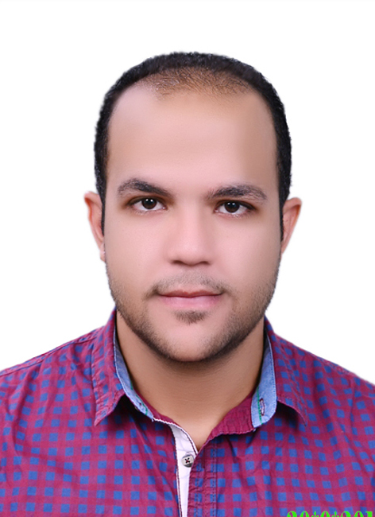
Name: Ahmed Hashem Abdullah Ali Hashem
Profession: Civil Engineer
Profile: Male
Address: Ekhnaway -Tanta – Gharbia – Egypt
Date of Birth: 1-12-1993

Ahmed Hashem Abdullah  Bachelor of Engineering ( Civil Department)  Class 2016  . | Mobile: +201114111827  E-mail: Ahmedhashem3322@gmail.com

Objective:

Seeking a position as a Civil Engineer in an organization where I can benefit my employer by implementing my acquired talents, experience to the best extent, and enhance my practical knowledge and abilities simultaneously.

Academics:

- Bachelor of Engineering (5 years course) (Oct. 2011 to Aug. 2016)
Department of Civil Engineering (Overall Grade: Very Good)
Percent: 79.2%
Tanta University

- Graduation Project: Construction Project Management & Planning.
(Grade: Excellent)
- Graduation Thesis: Water Treatment Plant.

Training:

- Eemar Al-Huda residential tower at Tanta 13 floors ( constructed by Eemar Aldelta co. )
- Residential tower in 11 floors at Tanta (constructed by Eemar Aldelta co.)
- Multi-storey garage in 7 floors at Tanta (constructed by Eemar Aldelta co.)
- Al-Rowad High School at Tanta (constructed by Al-Sawaf office)
- Primary school at Sanadid – Tanta ( owner Educational buildings authority )
- Expansion of high-way between Tanta-Alex (constructed by The Arab Contractor co. )

Key Skills:

- Good ability to handle projects on own and in team.
- Good Knowledge in Concrete Construction and dealing with its structure.
- High Technicality in Technical Office Work
- Good Knowledge in Finishing & Interior Designs

Computer Skills:

Engineering :

- Auto CAD 2D
- SAP
- Primavera
- Pert master Project Risk

Others:

- ,Windows 7, 8 & 10
- Microsoft Office (Word, PowerPoint & Excel) .

Hobbies:

- Reading
- Football
- Swimming
- Travelling

Languages:
- Arabic ( Mother Tongue )
- English ( Very Good )

