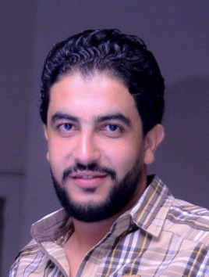

**DIAA Mohamed Ahmed Mosalam**

**Contact Information:**

+201098945457, +201223508756

civildiaamoslam45@gmail.com

haram, Giza, Egypt

**Education:**

College:Faculty of Engineering, Tanta University

Graduation Project: *construction progect management*

Year of Graduation: 2015

Project Grade:Excellent

**Skills:**

**Languages:**

Arabic (Native)

English (Very Good)

**Engineering Software:**

AutoCAD

Sap2000

primavera

exel,word

**Computer:**

Different Windows Platforms

Microsoft Office

Internet Programs

**Personal:**

High communication skills

Ability to work as a team member

Reliable and Flexible

Organized

Work under high pressure

**Experience:**

**Work:**

Novmeber2015 till febreuary2016 at Marwa Company for Reconstruction and Development

Febreuary2016 till June 2016 at memarmisr for Engineering and Contracting

(Construction of industrial wastewater treatment plants).

July 2016 till now at Herra for contracting and supplies.

(construction of the palace of culture in bani mur assuit and al adysat in luxor)

**Training:**

2013 summer training: The Arab Contractors Company.

2012 summer training: EL-tameoz Company

2011 summer training: Eamar el delta Company

**Personal Information:**

Nationality: Egyptian

Date of Birth: 05-04-1990

Marital Status: Single

MilitaryService : *Exempted*

***Thanks & Regards….***