**C.V**

**Personal Information**

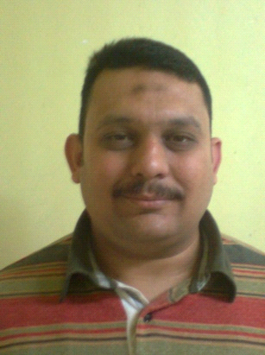

Name : Mohammed Frahat Marghany Frahat

Date of Birth : 14 April 1977

Nationality : Egyptian

Religion : Muslim

Marital State : Married

Military Service : Exempted

Address : 5 Elkods St, Ezbet Elshal, Mansoura, Egypt

Mobile : +201062628599- 0201276537781

E-Mail : mohamedfrahat293@yahoo.com

**Education**

Diploma in Technical Institution (Civil Department) 1998

Certificate of AutoCAD 2D (Information Technology Center (Mansoura))

**Work Experience**

From 1998 till now: Working as a draftsman using AutoCAD (2D) in “Concrete

for engineering consultancy” in Mansoura

Specific experience in hospitals, governmental buildings, residential towers and villas

**Computer Skills**

* AutoCAD (2D)