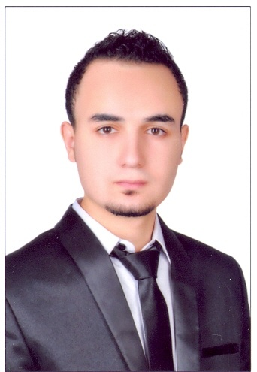**Mohamed Moneer Riad Elfayoume**

**(+2)01067130601**

**(+2) 01125008665**

[**muhamed.moneer@yahoo.com**](mailto:muhamed.moneer@yahoo.com)

[**muhamedmoneer@gmail.com**](mailto:muhamedmoneer@gmail.com)

|  |
| --- |
| **Objective:** |

Seeking for new Opportunity in Multi- National Company, able to Improve My Skills, Practice and add to my Knowledge, Search to learn more Information in my Career at Civil Engineering and Construction.

|  |
| --- |
| **Personal Information:** |

**Date of Birth:**1/7/1991

**Nationality:**Egyptian

**Marital Status:** Single

**Military Service:** postponed

**City : Alshorouk city**

|  |
| --- |
| **Education:** |

|  |
| --- |
| **College** B.S . Faculty OfEngineering. 2013 _2014  **Department** Civil Engineering section  **University** Tanta University  **Grade** Good  **Project** Soil Mechanics and Foundations  **Project degree** Very Good |

|  |
| --- |
| **Languages:** |

|  |  |
| --- | --- |
| **Arabic**  **English** | Mother Language  Very Good |

|  |
| --- |
| **Training Courses:** |

1_Professional site engineer (*HassanKandeel* ) .

2_OSHA CONSTRUCTION SAFETY and HEALTH .

|  |
| --- |
| **Computer Skills** |

Good using of MsOffice,Internet, Autocad and Sap,Etabs,Safe,CSIcolumn .

|  |
| --- |
| **Experience:** |

1_ Working now at Talaat Moustafa Group Holding Company at the Capital Cairo .

2_ Previously worked at Alrowad company for construction .

3_ Training at Arab Contractors company .

4_ Training at Emaar El Delta company .

|  |
| --- |
| **Intere­sts** |

Creativity, inspiration, meditation, reading & traveling.

I hope to be one of your team .

**References Furnished upon request**