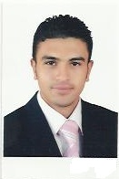 | Proposed Position:….  summary  Eng. Atef Abdelgalil Elsayed Dawood has a good experience in construction industry for 8 years especially in the field of construction has worked in projects construct villas , residential buildings , participated in the calculation of quantities and the work of the estimated cost of the projects also has worked as an executive in sanitation projects , industrial especially pumping stations sewage and industrial also has worked as consultant engineer in the office of Ahmed Al-mousaeng’g consultants, where has worked consultant engineer on construction projects, schools and educational buildings of the Ministry of Education, Saudi Arabia. has excellent communication skills, highly trustworthy, discreet and ethical, strong analytical , good in solving problems and resourceful in the completion of projects, effective at multi-tasking.  he want a challenging position with potential promotion and increasing knowledge and experience where skills and abilities can be utilized and according to his specialization, educational background and experience. .

Eng. Atef Abdelgalil Elsayed Dawood

Contact Information:

35 Moneer Elsheshtawy street- Abu Shaheen.  Almahalla Alcobra city- Algharbia – Egypt. | Address
(mobile) 002-01229256824.  (Home) 002-01124776663. | Phone
atef_dawood1@yahoo.com. | E-mails

Personal information:
Nationality | Egyptian.
Birth date | February18, 1986
Religion | Muslim
Gender | Male.
Marital status | married.
Military status | Final exempted.
Driving license | Available in both Egypt and Kingdom of Saudi Arabia.
Education

2003 – 2008 |  | University: Tanta University.  Civil Engineering, B.Sc. 2008. “Total degree : Good”  Project: structure analysis project. “ Degree : Excellent”

Technical Skills

AutoCAD active user.
SAP 2000 active user.
Microsoft Office Applications (Word, Excel, Power Point, Internet).
SAFE v.12.

Language

Arabic | Native Language
English | Advanced

Relevant Experiences

08/2008 – 7/2009   | Site Engineer  DEMA , 6 October City , EGYPT  Worked at 6 October City in construction of villas and residential buildings.  Participated in constructing residential building (concretes and finishing) & factories (FAIRY&ALAWAEL) and office work from site investigation and digging reaching finishing project.
07/2009– 07/2011  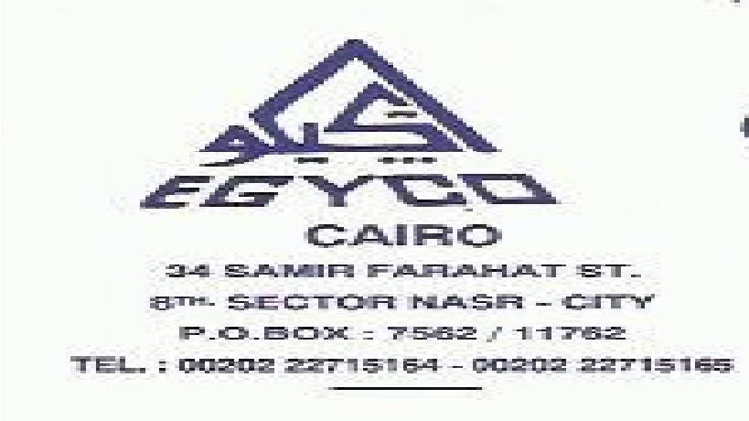 | Site Engineer  ALNASR for buildings and structures "EGYCO", Cairo , EGYPT  Work at Almahalla Alcobra city , Egypt in site Sewage pumping stations and Industrial sewage pumping stations.  Participated in calculations of quantities in construction of sewage and industrial lift stations also participated in the preparation of extracts in that period.
08/2011 – 07/2015   | Consultant Engineer  Ahmed Al-mousaeng’g consultants , Damam , kingdom of Saudi Arabia  Work at ministry of education in kingdom of Saudi Arabia as a consultant engineer on the educational “schools” and administrative buildings.  Participated in the development of assays for projects at this period.
08/2015 – till now | Executive manager  Al-roaya company – new heliopless – Egypt  Work as executive manager for constructing “ teriomf spa“ in new heliopless that content of 20 buildings .

Certificates:

Civil engineering   | B.Sc.; TANTA University.
Sap 2000   | Source Institute.
AutoCAD   | Mansoura University .
Experience certificate | From DEMA, 6 October City, EGYPT.
Experience certificate | From ALNASR for buildings and structures "EGYCO", EGYPT.
Experience certificate | From Ahmed Al-mousaeng’g consultants, kingdom of Saudi Arabia.
Experience certificate | Ministry of education “kingdom of Saudi Arabia”.

