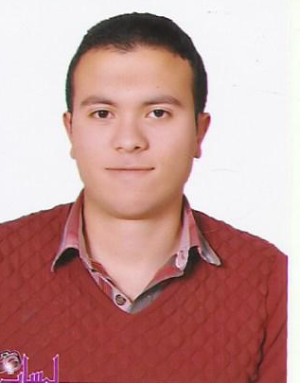

Personal data:-
Name : Hesham Elmor
Gender : male
Religion : muslim
Date of birth : 30 / 9 /1992
Nationality : Egyptian
Address : Mansoura
E-mail address : eng.hesham.elmor@gmail.com
Mobile no : 01016674080 / 01274528019

Studying file:-
Qualification : Bachelor of civil engineering
Grade : good
Graduation : 2014
Project mmmm : Project management
Project degree : Excellent

-Training courses

1- Autocad
2- Revit Structure
3- Primavera
4- Hassan kandil for professional site engineer
5- Sap – Etabs - Safe
6- Csi Columns – Sap Design

Skills
1- Language skills:-
1- Arabic:-
Mother language
2- English:-
Very Good

Experiences:-
1- Training in Mansoura University in New Damietta from 20/1/2014 to 20/7/2014
2- Worked as Site Engineer in El Ashry Contracting Office from 1/3/2015 to 1/12/2015
3- Worked as Site Engineer in Haraz Contracting Office in Finished of the National Bank of Egypt Branch of 10th of Ramadan from 1/1/2016 to 14/4/2017
4- Worked as Site Engineer in El Rahab Comtracting office in the new capital from 15/4/2017 to now

About me:-

Self motivated, Dynamic, has the effort to work under pressure, ambitious,

Responsible in establishing excellent customer services by providing them assistance to cater their needs

Great honor to be a member in your teamwork

