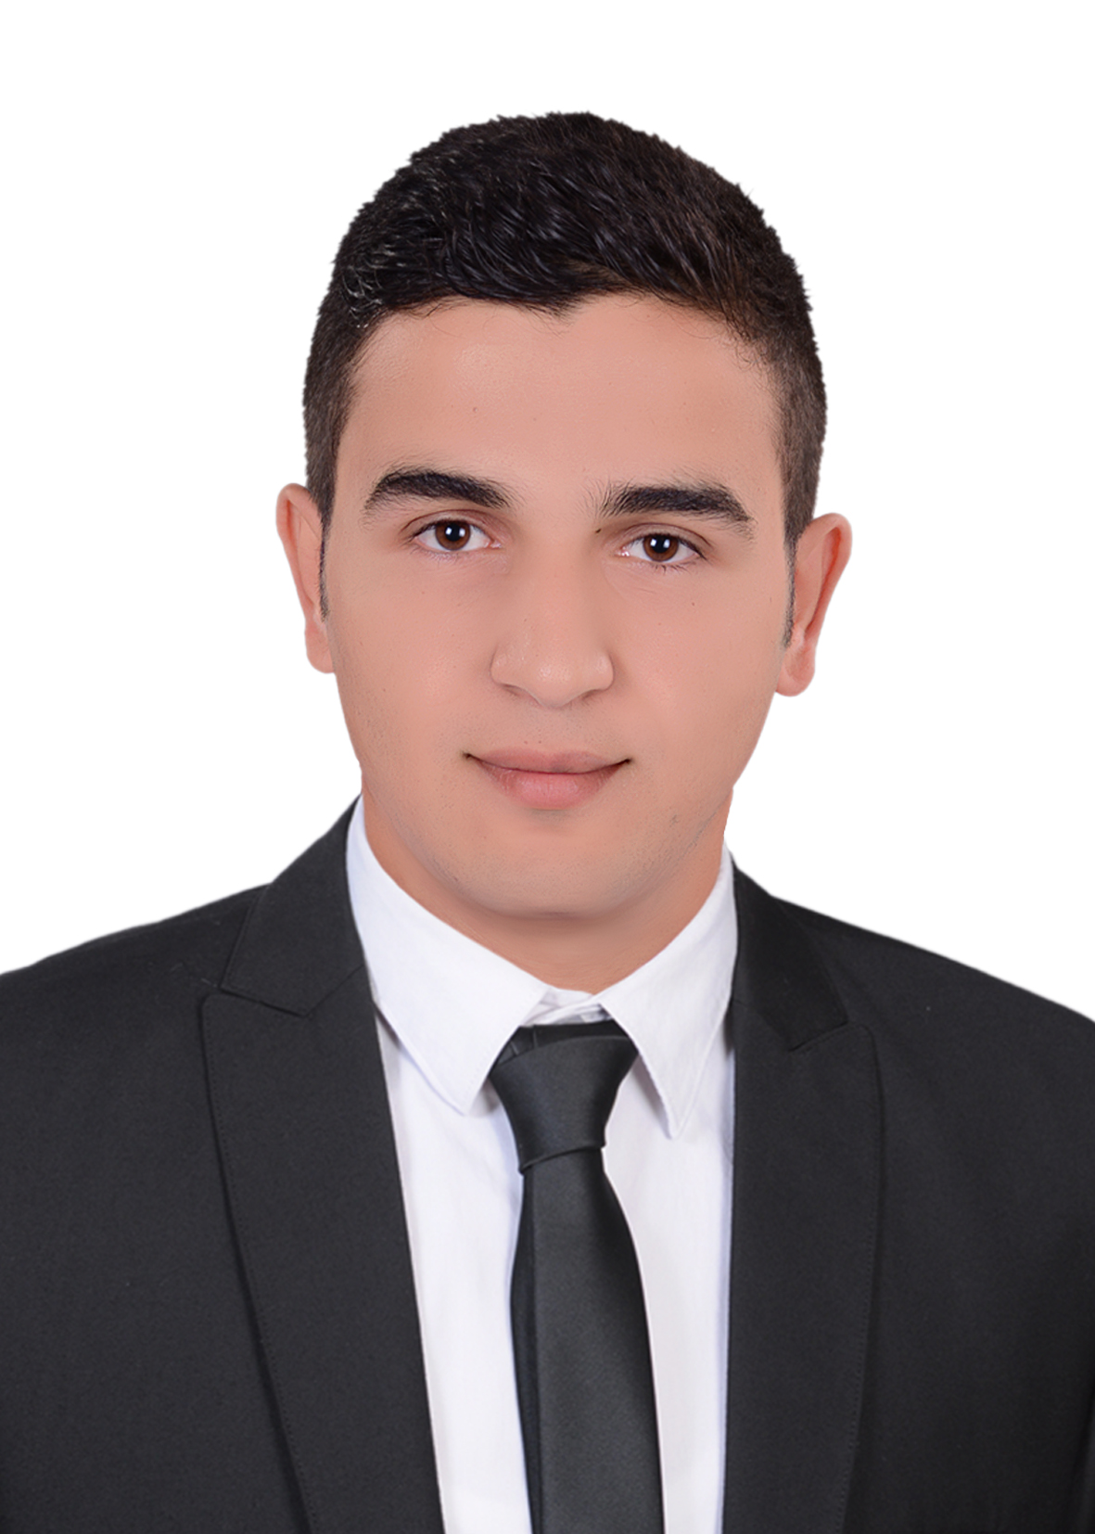
Curriculum vitae

Personal data:-
Name : Mohamed Abd Elkader Hassan Aboshady
Gender : male
Religion : muslem
Date of birth : 1-August-1994
Nationality : Egyptian
Address : Al-ebrahimia_kutour _Al-Gharbyia _Egypt
E-mail address: aboshady505067@yahoo.com
Telephone : 040- 2568443
Mobile no : 01011940035
Studying file:-
Qualification : He obtained his civil engineering degree
Grade : Very Good
Graduated from: science valley of academy
Project : concrete project
Project degree : very good
Graduation year: 2017
-Training course
* He trained in ARB CONTRACTORS COMPANY for two months
He has completed the training program “structural design diploma” Included *
Principles of Architecture design –statical system
1- Auto cad program professional
2- Sap program
3- Etabs program
4- Safe program
5- CSI column program
6- Excel
❖ Personal
Ability to work independently or undergo team work. *
Ability to learn new tasks quickly in respect to job needs.*
* Ability to work under stress.
*Self-motivated, target oriented and organized.
*Ambitious and loving to work
*Time management
*Strategic and creative thinking
*Responsibility
*Competitive
Computer Skills
Microsoft Office 2003, 2007, 2010, 2013: Word, Excel and PowerPoint.

Language skills: -
1- Arabic: = (Mother language) 2- English: = very good

