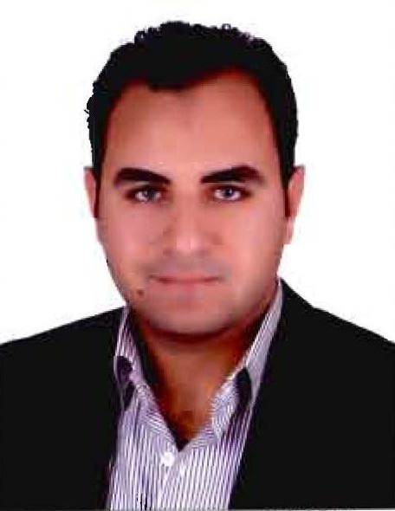
Ahmed Mohamed Badr Etman

Civil Engineer
          - E-mail: ahmedetman2025@gmail.com
          - Mobile: 01200244532_01228899807-01013745255
          - Military status : Temporary Exempted.
          - Marital status : Single
          - Date of Birth : 19th of September1991

OBJECTIVE
Work for an International Company to improve my abilities and work experience, and help in its progress and development. Seeking a challenging profession in a strong growing reputable company in the field of civil Engineering where I can further enhance my experience in a professional working environment.

EDUCATION
FACULTY OF ENGINEERING, TANTA UNIVERSITY
[CIVIL ENGINEERING DEPARTMENT]
- 4th year grade : Excellent (86.4%) - Graduation year : 2013
- Cumulative grade: Very good (76%)
      - Graduation Project: Soil mechanics and design of Foundation.
      - Graduation Project grade: Excellent.

EXPERIENCE
1st October 2015 till Now: (Egypt)
Job title: Quality Control Civil Engineer
Company: Consortium Siemens-Orascom Construction Industries
Project: Al-Burullus (4800 MW Combined Cycle Power Plant) Project.
Responsibilities:
- Assure the full compliance of the executed works.
- Perform the inspection for all successive activities to ensure compliance with the project specification.
- Ensure full documentation for the works inspections and close the Non Conformance Report (NCR) & (QR).
- Handover inspected activities to the Owner (GOE) Preparing Turnover Packages.
Scope of work :
- Pilling (Bored Piles- Driven Piles).
- Mass Concrete works.
- Switch Yard Area (Concrete works-Finishing works) at (GIS Building-GIS Control –Overhead Line Gantry).
- Power Block (Gas Turbine Generator foundation)-Bypass Stack Foundation. HRSG (Heat Recovery Steam Generators) foundation-PCC (Power Control Center Buildings)-(Steam Turbine Generator Foundation & Building-Gas Final Filter foundation) Civil Works.
- MV Auxiliary Generator Transformers.
- Water Structure Concrete works (Cooling Tower)

1st March 2015 till 15th September 2015: (Saudi Arabia)
Job title: QA/QC Civil Engineer
Company: Azmeel Contracting Company
Project: King Faisal University Extension (KFU)
Consultant: Abdullah Alsaif & Partners Company
Responsibilities:
- Assure the full compliance of the executed works.
- Perform the inspection for all successive activities to ensure compliance with the project specification.
- Handover inspected activities to the consultant.
- Review all the projects specifications related to my scope of work.
- Inspect all the materials delivered to the site to ensure compliance with the approved material documents as well as the project specifications.
- Ensure full documentation for the works inspections and close the Non Conformance Report (NCR) & (QAN).
- Reviewing shop drawing.
- Familiar with of engineering International Technical Specifications & Standards.
Scope of work :
- National Research Center for Giftedness and Creativity Building.
- Reinforced Concrete Works. (Raft, Columns, Slabs).
- College of Literature for Boys.
- Reinforced concrete works(Raft,columns,slabs)
15th June 2014 to 25th February 2015 :( Egypt)
Job title: Quality Control Civil engineer
Company: Orascom Construction Industries.
Project : AlQattamia Bridge (Nasr City)
Consultant: Dr.Sabri Samaan Office
Responsibilities:
- Assure the full compliance of the executed works.
- Ensure the full compliance and application of standard methods for quality control procedures.
- Perform the inspection for all successive activities.
- Handover inspected activities to the consultant.
- Close the punch list items.
Scope of work :
- Pilling (Bored piles)
- Column, Frames, Slabs casted in situ.
- Prestressed Concrete Beams.
- Precast Concrete Slabs

- 1st September 2013- to 10th June 2014-(Egypt)
Job title: Civil Site Engineer
Company: Besix-Orascom Construction Industries.
Project : Giza North Power Plant (2250 MW Combined Cycle Power Project)
Consultant: PGESCO
Responsibilities:
- Assure the full compliance of the executed works.
- Arrange the sequence of the executed activities.
- Handover inspected activities to the QC team and consultant.
Scope of work:
- Underground (manholes& inspection chambers) and Infrastructures concrete works (ramps & slab on grade).
- Power Block (Chemical injection system unit -emergency diesel generator – condensate pump can) foundation.
- Finishing works for heat recovery steam generator rooms (HRSG) and hydrogen building.
- Wall Fence and guard towers.
- Storm drainage (catch basin-storm drainage trench-oil separator tank).
Training
- Summer 2011 Construction of a factory in Sadat City at ACE Company.
- Midyear training 2012 at OCI Company in 57357 Hospital at Tanta.
- Summer training in ministry of housing from 1/7/2010 to 15/9/2010 at Housing Project in Kafr Elzayat City.

Courses Attended
    - AutoCAD (Certification Autodesk August 2013)
    - Time Management-Power Potential Energy.
- Microsoft Office “Word – Excel – PowerPoint”
- SAP 2000 V 11
- Upper intermediate conversation English language (MIDEAST)
- Computer Maintenance

SKILLS AND ACTIVITIES
Languages
    - Mother tongue [Arabic]
    - English [Very good W&S ]
Soft Skills
Highly motivated personality, communicating, Listening, Analytical thinking, Decision making, Planning,
Teamwork, Interpersonal Skills, Developing Me, Motivated, Business Sense, Adapting to Change, Flexible,
Working under pressure and have no problem to work anywhere.
Reference:
Furnished upon request

