PERSONAL INFORMATION | 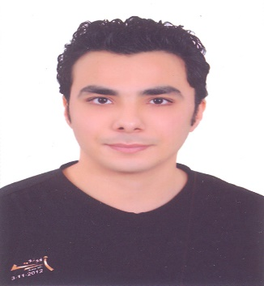  Hossam Mohammed Hassin Kolieb
 | Tanta,ELgharbia, Egypt
(+2) 0403460443(+2) 01026323214
(+2) 01001851085

HossamKolieb@gmail.com

Date of birth: 2/11/1989

Address: Tanta,Gharbi

Marital Status : Done

Career Objective | Seeking for a career relative to the field of construction of concrete structures where my experience can be applied and further developed.

EDUCATION & QUALIFICATION
September 2007 – July 2012 | B.Sc. in Civil Engineering  Department of Structure.  Faculty of Engineering, Al-azhar University.
- Accumulative degree: Good
- Final Year Grade: Good.
- Graduation project: Structure Analysis
- Grade Of Project:Good.

Duties
- Reporting on contract progress and advising on actions needed to keep the project to the agreed programme.
- Providing mentoring and encouragement to others to help them achieve their maximum level of performance.
- Dealing with internal and client technical queries and requests.
- Producing calculations and drawings.
- Advising and liaising with project stakeholders and consultants.
- Checking of detailed designs and drawings.

Experience
- Worked at National Company for Construction for two years.
- Worked at Amigo Group for 6 months.
- Worked at smart building for now.

COURSES

- Mastering in AutoCAD.
- SAP 2000
- ICDL

OTHER SKILLS

COMPUTER SKILLS | - Operating Systems: Windows 8.1, 7, XP, Linux(Ubuntu – Redhat) and Windows Server 2003.  - Applications: MS office applications (Excel, Word & PowerPoint)
LANGUAGE SKILLS | - Arabic.  - English (very good).
PERSONAL SKILLS | - Problem solving.  - Professional manner.  - Safety conscious.  - Can handle stress.  - Always pro-active.  - Attention to detail.  - Logical thinker.  - Communication skills.

I am happy to supply these on request

