261 Yasmin 5th settlement,
New cairo, Cairo, Egypt
Home : +2-02-22743103
Mobile : +2-0100-2586591
E-mail : hishamtraad@hotmail.com
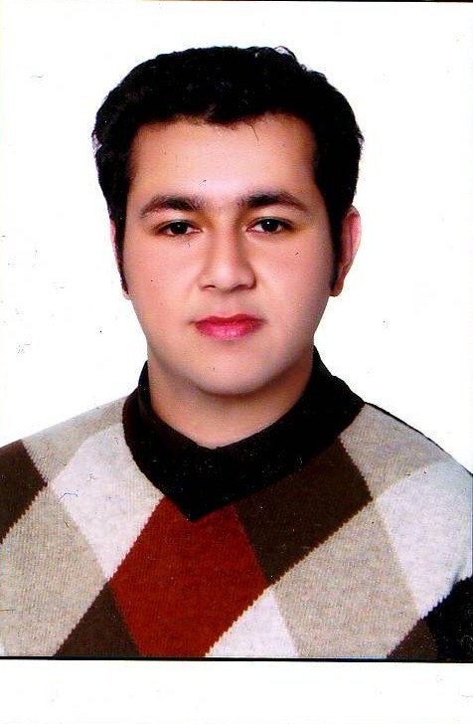

Hisahm Zakaria Fathy Traad

Personal Data :
- Date Of Birth : 1st of July , 1989
- Nationality : Egyptian
- Religion : Muslim
- Marital : married
- Military : Exempted
- Own Car : Available
- Driving License: Available

Education :
- Master of engineering from Ain Shams University 2014 (structure civil engineering) With GPA 3.55 form 4.00
Research point (comparative study between calculation of punching stresses in Egyptian code)

- B.Sc. Civil Engineering from Higher Technological Institute
GPA : 3.88 From 4.00
Sort on College : The First.
Grade : Excellent with grade of honor.
Graduation project : Design social club builds.
Graduation project Grade : Excellent.
Graduation year : 2011.

- Graduated from Futures language schools with a score of 90%

Work situation :
- Lecture at Faculty of Engineering at higher technological institute (HTI) since 2011.( 3 days per week )
- structure engineer
  - e construct (2011 for 3 months )
  - Asmaa group (2012 to 2013 )
  - Dr Mahmoud el Nagar office (2013 to 2014 )
  - Private works for many engineering offices
- Survey experience

- site and supervision engineer for :
                - 5 villas in new Cairo, mirage city and rehab city ( concrete construction and finishing ) since 2012
                - 2 buildings ( 17 floors ) concrete construction –ring road –since 2013
                - Number of finishing for flats at new Cairo , Nasr city , Madinaty , Rehab city and dreem land ( 2014 and 2015 )
                - Supervision for 5 building at gardenia project ( el Salam group )

Career Objective :
Looking forward to have the opportunity of a good position in a Multinational company in which I can enhance and utilize my education, skills and increase my experience.
Summer Training :

Trained in constructing hospital in Cairo city, the contractor: the arbic contractors.
From 08-08-2009 To 03-09-2009

Trained in E-Construct for design high rise buildings .
From 18-06-2011 To 13-08-2011

Trained in constructing group of Building in Madinaty city.
From 23-05-2009 To 23-07-2009

Productive training device for Construction and building character.
From 25-05-2008 To 24-07-2008

Trained in constructing group of building in Zahraa new city for Asama Group.
From 22-05-2010 To 23-07-2010

Computer Skills:
Course name | Grade
All Microsoft Windows Platforms | : Excellent
ICDL | : Excellent
AutoCAD 2D | : Excellent
E-TABS | : Excellent
SAP2000 | : Excellent
SAFE | : Excellent
CONCISE | : Excellent

Hobbies :
- Reading – writing - smart games(games for brain) - Traveling

Languages :
- Arabic is a mother tongue.
- Excellent command of spoken and written English.
- French : bad
Personal Skills:

- Excellent communication skills.
- Excellent Presentation skills.
- Decision maker.
- Can work on shifting and fields outside Egypt.

