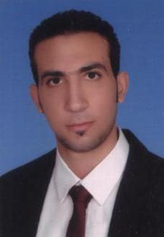

cv

**Mostafa yehia Ahmed**

**Personal Data:**

* Gender : Male
* Date Of Birth : 1/10/1989
* Nationality : Egyptian
* Military status : ended
* Marital status : Married
* Driving license : Valid
* Mob : **01121020778&01229955706**
* E-mail : Darshnet2010@yahoo.com

:Mostafayhia2222@gmail.com

**Education:**

Bachelor of Commerce Al-Azhar University2013.good

**Career Objective**

-Successful professional with experience in financial accounting.

-Extensive experience in taxation and Accounting.

-Expertise in financial planning, reporting, and payroll.

**Practical Expertise**

**-conccret puls for eng &const:** **Accountant**

**May2016 present --Mohamed alsaidy Office: Accountant**

**March 2015** May 2016

**-egy Pharma :Accountant**

**Aug 2013 :** **February2014**

**Skills:**  
-Experience in global business at macro level.  
-Excellent business communication skills.  
-Experience in preparing corporate taxes.  
-Understanding of computer applications related .  
**Computer Skills:**

* Windows : Excellent
* MS Office : Excellent
* Internet Use : Excellent
* Photoshop : Excellent

**.** oracle : Excellent **Languages:**

* Arabic : Native language
* English : good

(References are provided when needed)

